SUBCOURSE EDITION
QM 3507 A

PLAN FOR AIRDROP OF SUPPLIES



PLAN FOR AIRDROP OF SUPPLIES

Subcourse Number QM3507

EDITION A

United States Army Combined Arms Support Command
Fort Lee, Virginia 23801-1809

5 Credit Hours

Edition Date: September 1991

SUBCOURSE OVERVIEW

This subcourse is designed to teach you how to plan for the airdrop of supplies. Contained within this subcourse is instruction on how to determine the supplies and the equipment that you need and how to compute the number of sorties, the sortie time, and the minimum number of aircraft that you require. This subcourse also contains instruction on how to determine the amount of the airdrop equipment that you need, the amount of the rigging effort, and the number and type of cargo parachutes that you require. Also contained within this subcourse is instruction on how to select the drop zone (DZ), how to mark the DZ, how to identify DZ personnel, and how to survey the DZ.

There are no prerequisites for this subcourse.

This subcourse reflects the doctrine which was current at the time it was prepared. In your own work situation, always refer to the latest official publications.

Unless stated otherwise, the masculine gender of singular pronouns is used to refer to both men and women.

TERMINAL LEARNING OBJECTIVE

ACTION: You will identify the procedures to plan for the airdrop of supplies.

CONDITION: You will have information from Field Manual
(FM) 10-1, FM 10-400, FM 10-500-1, FM 10-500-3,
FM 10-500-2, FM 10-500-53, FM 10-516, FM 10-517,
FM 10-533, FM 29-51, FM 57-230, FM 100-10, FM 57-220
FM 101-10-1/2, FM 100-27, Air Mobility Command
Regulation (AMCR) 3-3, MACR 55-60, and 55-40.

i QM 3507

STANDARD: To demonstrate competency of this task you must achieve a minimum of 70 percent on the subcourse examination.

QM 3507 ii

TABLE OF CONTENTS

Section Page

Subcourse Overview i

Lesson: Plan for Airdrop of Supplies 1-1

Part A: Airdrop Request Procedure 1-2

Part B: Drop Zone Coordination Procedures 1-40

Practice Exercise 1-67

Answer Key and Feedback 1-69

Appendix A: List of Acronyms A-1

Appendix B: Publication Extracts B-1

FM 10-500-53 Airdrop of Supplies and Equipment:
Rigging Ammunition, October 1991

iii QM 3507

LESSON

PLAN FOR AIRDROP OF SUPPLIES

Critical Task: 03-5102.02-0001

OVERVIEW

LESSON DESCRIPTION:

In this lesson, you will learn how to determine the supplies and equipment you need for an airdrop. You will learn how to compute the number of sorties, sortie time, minimum number of the aircraft that you require, the amount of rigging effort, and the number and the type of cargo parachutes that you require. You also will learn how to select the DZ, how to mark the DZ, how to identify DZ personnel, and how to survey the DZ.

TERMINAL LEARNING OBJECTIVE:

ACTION: Plan for the airdrop of supplies.

CONDITION: You will be given information from FM 10-1,
FM 10-400, FM 10-500-1, FM 10-503, FM 10-500-2,
FM 57-220, FM 10-500-53, FM 10-516, FM 10-517,
FM 10-533, FM 29-51, FM 57-230, FM 100-10,
FM 101-10-1/2, FM 100-27, AMCR 3-3, AMCR 55-60, and
AMCR 55-40.

STANDARD: Planning for the airdrop of supplies will be in
accordance with FM 10-1, FM 10-400, FM 10-500-1,
FM 57-220, FM 10-503, FM 10-500-2, FM 10-500-53,
FM 10-516, FM 10-517, FM 10-533, FM 29-51, FM 57-230,
FM 100-10, FM 100U-0-;1/2, FM 100-27, AMCR 3-3,
AMCR 55-60 and AMCR 55-40.

REFERENCES: The material contained in this lesson was derived
from the following publications: FM 10-1,
FM 10-400, FM 10-500-2, FM 10-503, FM 10-500-2,
FM 10-500-53, FM 10-516, FM 10-517, FM 10-533,
FM 29-51, FM 57-230, FM 100-10, FM 101-10-1/2,
FM 100-27, AMCR 3-3, AMCR 55-60, and AMCR 55-40.

1-1 QM 3507

INTRODUCTION

The airdrop of supplies is necessary for unit survival in a number of tactical and nontactical situations. Your responsibilities as an airdrop officer include computing the following:

- Number of the sorties that you need.
- Minimum number if the aircraft that you need.
- Amount of the time that you need to rig the loads.
- Compute the airdrop equipment required to support the airdrop.

You will receive instruction in each of these areas. In addition, this subcourse provides instructions as to how to calculate the sortie time.

PART A - AIRDROP REQUEST PROCEDURE

1. Responsibilities of Units Requesting Airdrop Resupply.

The unit requesting airdrop resupply has several important responsibilities. These are reflected in actions that the requesting unit must take either before or after submitting its airdrop request.

a. Actions Taken Before Submitting Request. Prior to submitting its request, the unit must determine what supplies and equipment are needed and where and when they should be dropped.

(1) Supplies and Equipment Needed. The quantities requested should be influenced by the hazards involved in conducting the airdrop resupply mission. For instance, the immediate need is ammunition. However, the unit may also need other supplies (such as water, rations, or medical supplies) before land lines of communication are reestablished. All of these supplies should then be requested at the same time. It is better to request more supplies than are actually needed than to have to make a second request within a few days.

(2) Drop Zone Location. The area where the supplies must be airdropped must be defined. The eight-digit coordinates for the center of the drop zone must be determined.

(3) Time and Date of Airdrop. When setting up the time and date for an airdrop, keep in mind the request is passed through TOC channels back to corps. At the corps level, supplies must be rigged for air drop, delivered to the departure airfield, loaded aboard delivery aircraft, and flown to the drop area. Unless the supplies are on a preplanned request, it usually takes more than eight hours

QM 3507 1-2

to receive supplies by airdrop.

b. Actions Taken After Submitting Request. After submitting its request, the unit must prepare to receive the resupply. The drop zone must be prepared, secured, and controlled and provisions made for recovery and retrograde of supplies and equipment.

(1) Drop Zone Preparation and Security. Most airdrop resupply operations will deliver supplies in A22 containers using either low-velocity or high-velocity parachutes. Therefore, little drop zone preparation is required. This type of resupply can even be used to deliver supplies to a drop zone that is covered with relatively short trees. Security around the drop zone will be required to protect the drop zone support team and the recovery party. See FM 100-27 for additional information on drop zone criteria.

(2) Drop Zone Control. Most airdrop resupply operations will be conducted without an Air Force combat control team. Therefore, the receiving unit must operate the drop zone. This includes communications with the Air Force crew flying the mission. FM 57-230 has more information on the drop zone support team.

2. Types of Airdrop.

Most airdrop resupply missions are conducted for units in the divisional area or forward of the forward line of troops (FLOT) for deployed special operations forces (SOF). Airborne forces are vulnerable during air movement. Air superiority is essential during the entire airborne operation. The ground force mission, the threat, and the location and the quality of the landing zone (LZ), DZ, or extraction zone (EZ) are important considerations when the type of delivery system is selected. The capability and the availability of airlift and fighter aircraft also may limit the scope of an airborne operation. Figure 1-1 shows the four types of airdrop. The following subparagraphs describe the four types of airdrop in more detail:

a. Free-Drop Airdrop. Use the free-drop airdrop infrequently, especially when airdrop equipment readily is available. You may free-drop nonfragile items such as baled clothing and fortification and barrier materials. DO NOT use parachutes or other devices to slow the rate of the descent of the free-drop supplies. Place some type of energy-dissipating material, such as honeycomb, around the supplies to lessen the

1-3 QM 3507

shock that occurs when the load hits the ground. The load descends at a rate of 130 to 150 feet per second.

b. Low-Velocity Airdrop. Use the low-velocity airdrop for all supplies and equipment that are certified for airdrop. Cargo parachutes reduce the rate of the descent to approximately 28 feet per second. Use one to eight parachutes per load depending on the weight of the load. Rig the items on airdrop platforms or airdrop containers. Place energy-dissipating material around the supplies or the equipment to reduce the shock that occurs when the load hits the ground. Use low-velocity techniques to airdrop fragile material, vehicles, bridging, and artillery.

c. High-Velocity Airdrop. High-velocity airdrop uses a small parachute that generates enough drag to hold the load in an upright position during its descent at 70 to 90 feet per second. Place the items to be airdropped on energy-dissipating material. Rig the items in an airdrop container. Deliver subsistence items, packaged petroleum, oils, and lubricants (POL); ammunition, and similar items by this type of airdrop.

d. Low-Altitude Parachute Extraction. Use the low-altitude parachute extraction (LAPE) technique to airdrop supplies and equipment from an aircraft that flies approximately 5 to 10 feet above the ground. Rig the load on a specially configured airdrop platform. Use webbing and load binders to hold the load on the platform. Place energy-dissipating material under the load to reduce the shock that occurs when the load hits the ground.

To extract the load, use one to three LAPE parachutes as the aircraft flies across the DZ. The load falls approximately 28 feet per second and slides across the EZ. The LAPE parachutes keep the load aligned with the EZ to prevent the load from tumbling and to help to slow its forward momentum.

To use the LAPE airdrop, you require a relatively flat, smooth area which requires special preparation. With few exceptions, you can use LAPE to deliver every item that you can deliver by low-velocity airdrop.

QM 3507 1-4

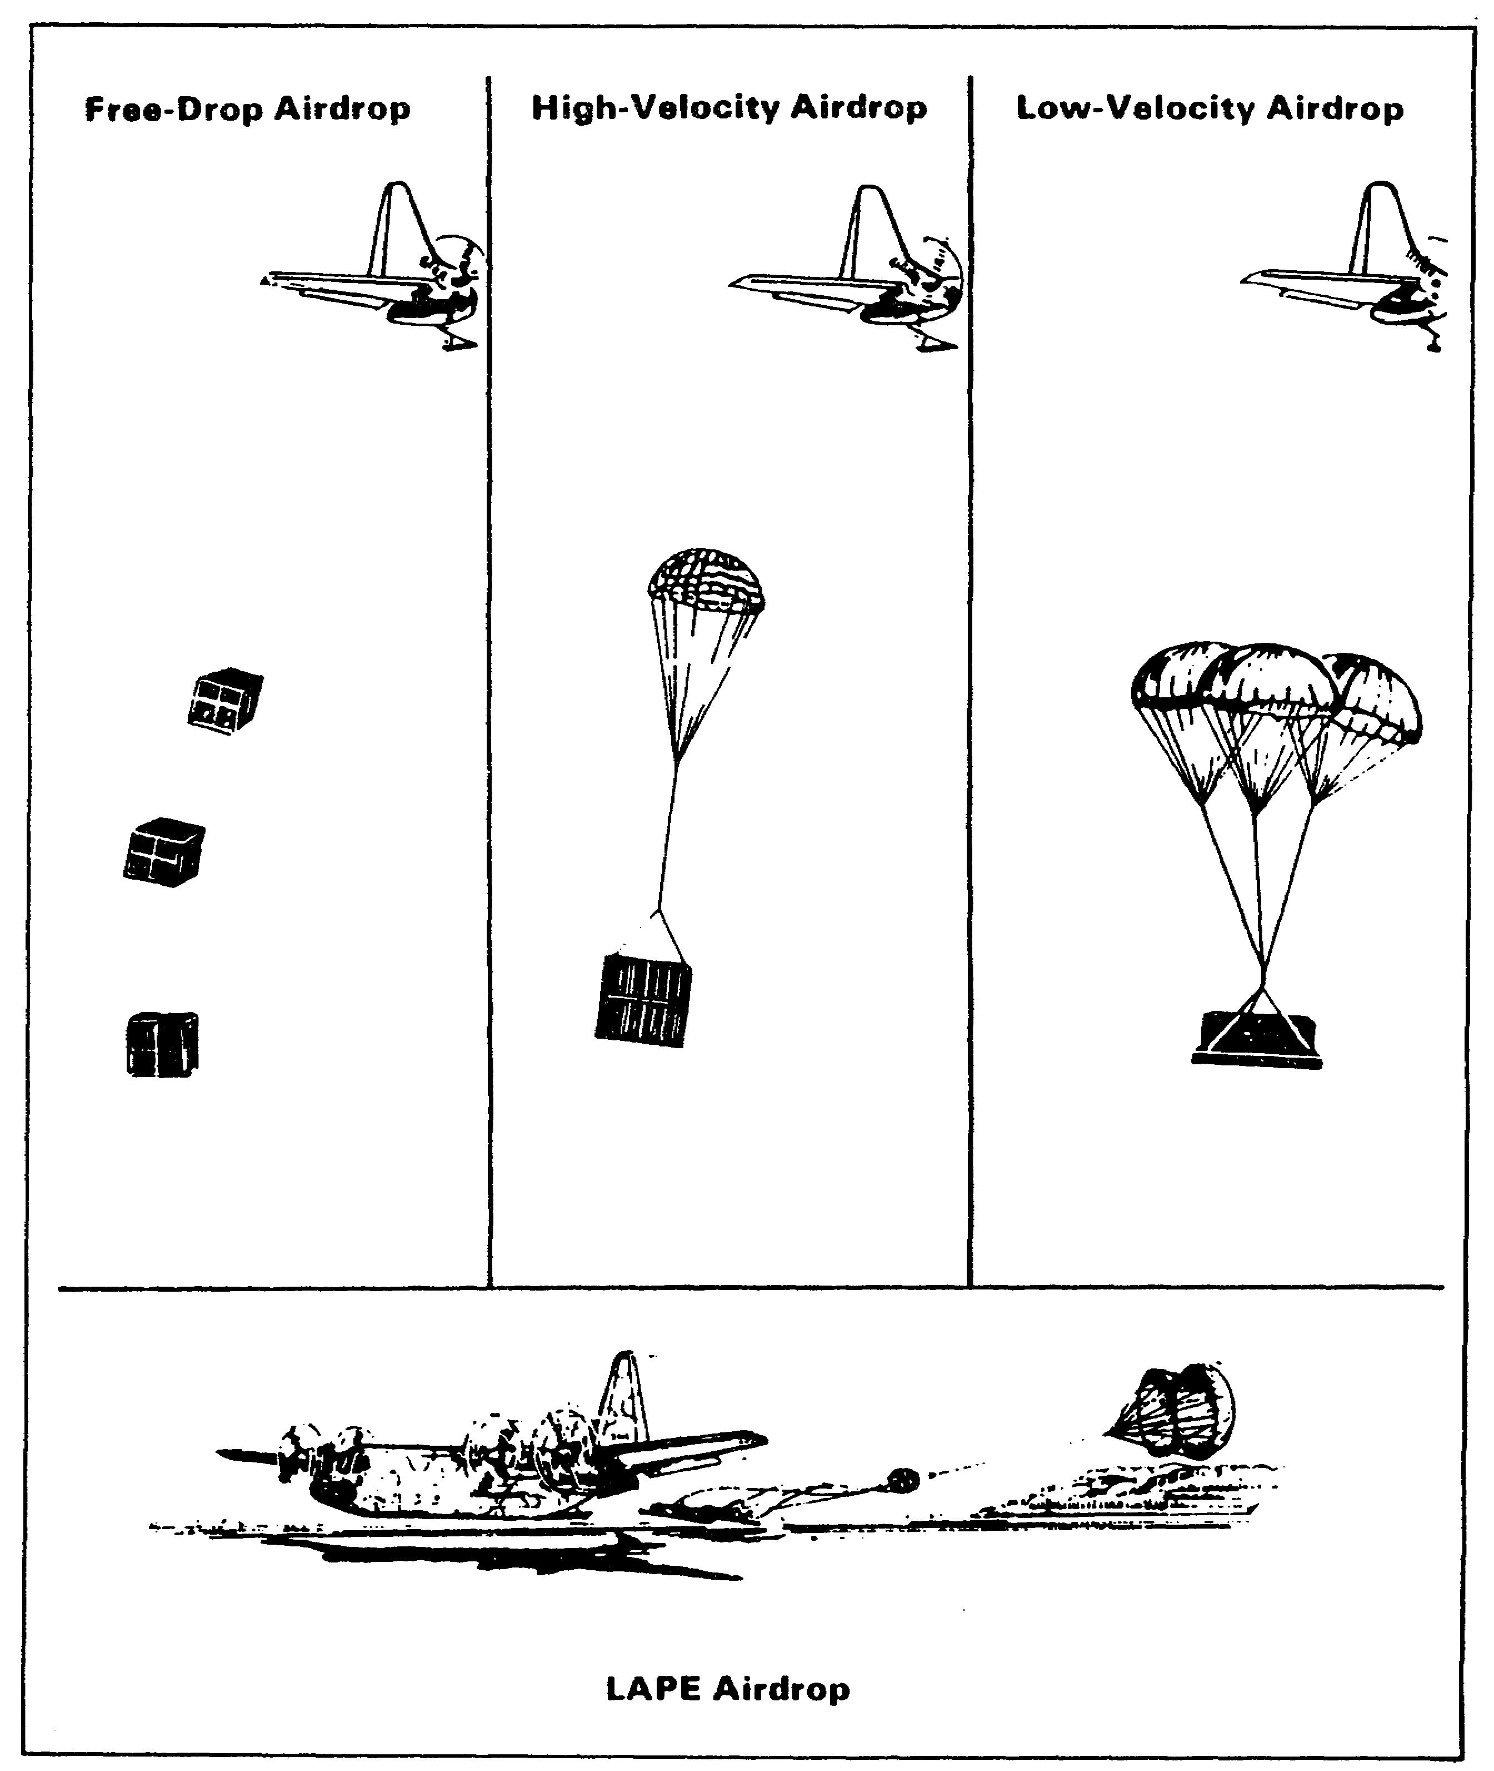

Figure 1-1. Types of airdrop

1-5 QM 3507

3. Methods of Releasing Airdrop Loads.

A knowledge of the methods of airdrop is important to the user and the planner who are involved in developing airdrop requests and equipment stockage requirements. The main concern of the unit that requests a mission is that the requested supplies arrive at the required time and the place in a usable condition. There are three primary and three secondary methods of releasing airdrop loads. The following subparagraphs describe these methods:

a. Extraction Method. The extraction parachute or the LAPE parachute pulls the load, rigged on an airdrop platform, from the aircraft cargo compartment. Use this method for all low-velocity and LAPE platform airdrops.

b. Door Load Method. Push or slide small bundles out the paratroop doors. Use this method mainly for the supplies and the equipment that you drop during an airborne troop drop.

c. Gravity Method. Before the drop, the pilot flies the aircraft in a nose-up attitude. The release gate of nylon webbing restrains the bundles in the aircraft. Cutting the webbing allows the bundles to roll out of the aircraft. The static line that is connected to the inside of the aircraft activates either the high-velocity or the low-velocity main parachute. Employ this method to deliver containers using both high-velocity and low-velocity techniques.

d. Secondary Methods. There are three secondary methods of airdrop. One method is to release a bundle from the cargo hook of a helicopter. The remaining two methods employ the SOF methods. One SOF method uses a bungee cord system as an aid to the gravity method. This system allows the airdrop of small bundles from relatively low-flying, high-speed aircraft. The other SOF method releases a bundle that is shaped like a bomb from beneath the wing of a jet (tactical) aircraft.

4. Airdrop Containers.

Pack these containers with supplies, disassembled equipment, or small items of ready-to-use equipment that are prepared for airdrop. Cushion these loads with honeycomb, felt, or cellulose wadding depending on the load requirements and the method of the airdrop. The number and the types of the parachutes that you require to stabilize the load and to slow its descent depend on the type of the container that you use, the weight of the load, and the type of the airdrop.

QM 3507 1-6

a. A-7A Airdrop Cargo Sling Assembly. The A-7A airdrop cargo sling assembly consists of four identical sling straps and four D-rings. Each strap is 188 inches long. Each sling strap has a parachute harness adapter (commonly called a friction adapter) at one end. The maximum weight of the container will vary according to the number of the straps. When two straps are used, 300 pounds is the maximum weight. When three straps are used, 400 pounds is the maximum weight. When four or more straps are used, the maximum weight is 500 pounds.

b. A-21 Cargo Bag Assembly. The A-21 cargo bag assembly is an adjustable airdrop container. It consists of a sling with a scuff pad, a fixed quick-release strap and assembly, two O-ring straps, three quick-release straps, and a 97- by 115-inch canvas cover. The A-21 cargo bag assembly has a load capacity of 500 pounds.

c. A-22 Cargo Bag Assembly. The A-22 cargo bag assembly is an adjustable nylon webbing container. It consists of a sling assembly, a cover, and four suspension webs. Rig the load with or without a cover. The standard skid for both low- and high-velocity airdrop is 48 inches by 48 inches. Use a 3/4-inch-thick skid board for a low-velocity airdrop and a 1 inch skid board for high velocity air drop. The weight capacity for the container is 501 to 2,200 pounds without the weight of the parachute. The height will vary, although it is not to exceed 83 inches with the parachute unless a specific rigging procedure authorizes an exception.

d. Double A-22 Cargo Bag Assembly. The double A-22 cargo bag consists of two A-22 cargo bag assemblies. Rig the load with or without covers. Use only six of the suspension webs. DO NOT mix nylon and cotton sling assemblies. Make the skid board of a 3/4- by 48- by 96-inch sheet of plywood. The weight capacity of the load is 900 to 2,200 pounds without the parachute's weight.

e. A-23 Cargo Bag Assembly. The A-23 cargo bag sling assembly is similar to the A-22 cargo bag sling assembly. However, it has an additional support web on all four sides with an additional D-ring on each side. The weight capacity of the load is 501 to 2,200 pounds without the weight of the parachute. Use the A-23 container assembly for high-altitude airdrop resupply system (HAARS) drops. You also may use the A-23 for A-22 drops.

f. Ammunition Containers. Handle explosives and ammunition with care at all times. The explosive element in primers and fuses are sensitive to shock and high temperatures. Rigging personnel must not drop, throw, tumble, or drag boxes or containers of explosives or ammunition. Complete round rigging (CRR) encompasses all the necessary munitions for the completion of the mission (for example, primers, propelling charges,

1-7 QM 3507

projectiles, and fuses) rigged on an airdrop platform or in a container. Authorize CRR only during wartime or periods of increased readiness. DO NOT authorize CRR during training exercises. Rig boxed ammunition and proximity fuses in the following positions:

- Rig boxed ammunition in the position in which it normally is shipped, with the box lid on top.

- Rig proximity fuses in the "nose-down" position. DO NOT use the fuses if the fuse box is damaged.

(1) A-22 Cargo Bag Used for Ammunition. Rig the airdrop items in their original shipping containers or repack them for airdrop. Refer to subparagraph 4c of this part of the lesson for A-22 container load weights.

(a) Low-Velocity Airdrop of Ammunition. Use the following special instructions when you rig A-22 cargo bags for the low-velocity airdrop of ammunition:

- Position the ammunition loads in the A-22 cargo bag for low-velocity airdrop as shown in the examples in Appendix B, on pages B-2, B-3, and B-4.

- Ensure that the A-22 cargo bags that you rig for airdrop are not more than 83 inches high, including the parachute, unless the AMC otherwise approves. Place a load that overhangs the edge of the standard 3/4-by 48- by 48-inch low-velocity A-22 skid lengthwise in the aircraft.

(b) High-Velocity Airdrop of Ammunition. Use the following special instructions when you rig A-22 cargo bags for the high-velocity airdrop of ammunition:

- Position the ammunition loads in the A-22 cargo bag for high-velocity airdrop as shown in the examples in Appendix B, on pages B-5, B-6, and B-7.

- Ensure that the A-22 cargo bags that you rig for airdrop are not more than 83 inches high, including the parachute, unless you obtain the prior approval of the AMC. Place any load that overhangs the edge of the standard 1- by 48- by 48-inch high-velocity A-22 skid lengthwise in the aircraft.

QM 3507 1-8

- When you use the centerline vertical restraint (CVR) system, ensure that the first two layers of honeycomb do not exceed 44 by 44 inches.

- Use a 1-inch plywood skid for all the A-22 cargo bags that you rig for high-velocity airdrop.

- If the base of the load exceeds 48 by 48 inches, then add a layer of honeycomb to cover the base of the load.

(2) A-7A Cargo Slings and A-21 Cargo Bags Used for Ammunition. The A-7A cargo sling and the A-21 cargo bags also are used in the airdrop of ammunition. The following subparagraphs describe the use of these containers:

(a) Low-Velocity Airdrop of Ammunition. Use the following special instructions when you rig A-7A slings and A-21 cargo bags for the low-velocity airdrop of ammunition:

- Position the ammunition loads in the A-7A cargo sling for low-velocity airdrop as shown in the examples in Appendix B, on pages B-8, B-9, and B-10.

- The minimum allowable weight of an A-7A cargo sling or an A-21 cargo bag, including the parachute, is 28 pounds per square foot, based on the largest surface area of the container.

(b) High-Velocity Airdrop of Ammunition. Use the following special instructions when you rig A-7A slings and A-21 cargo bags for the high-velocity airdrop of ammunition:

- Position the ammunition loads in the A-7A cargo sling for high-velocity airdrop as shown in the examples in Appendix B, on pages B-11, B-12, and B-13.

- Remember that the minimum allowable weight of an A-7A cargo sling or an A-21 cargo bag, including the parachute, is 28 pounds per square foot, based on the largest surface area of the container.

1-9 QM 3507

5. Airdrop Platforms.

Airdrop platforms, as shown in Figure 1-2, serve as the base on which to restrain supplies and equipment. These platforms also support the load during the extraction, the parachute deployment, and the recovery phases. They also spread the shock of the ground impact.

a. Types of Airdrop Platforms. There are three types of the platforms that are used in airdrop operations. The following subparagraphs describe each type of platform:

(1) Type II Modular Airdrop Platform. You can field-assemble the Type II modular airdrop platform that is shown in Figure 1-2 in 8-, 12-, 16-, 20-, and 24-foot lengths. The assembled platform is 108 inches wide.

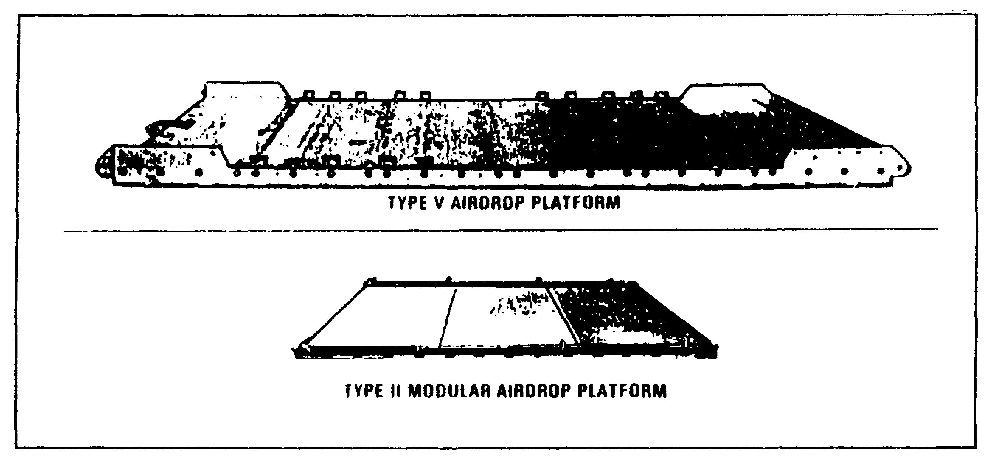

Figure 1-2. Airdrop platforms

(2) Type V Airdrop Platform. Use this type of airdrop platform for both low-velocity and LAPE airdrops. You can field-assemble the type V platform in 8-, 12-, 16-, 20-, 24-, 28-, and 32-foot lengths. The assembled platform is 108 inches wide. When you use this platform for low-velocity loads, you may remove the nose bumper.

b. Platform Airdrops. Platform airdrops consist of the low-velocity airdrop and the LAPE. The following subparagraphs describe these two airdrops:

QM 3507 1-10

(1) Low-Velocity Airdrop. A low-velocity airdrop delivers platform loads from aircraft at various altitudes. Use cargo parachutes to slow the descent of the loads to ensure minimum landing shock. The type and the number of cargo parachutes can vary as shown in Figure 1-3. Due to differing deployment characteristics, DO NOT mix parachutes of different types on the same load. You may airdrop loads with different types of parachutes and loads with different quantities of the same type of parachute from the same aircraft or element provided that you meet the following conditions:

- You have determined the airdrop altitude for the aircraft or the element by the type and the number of parachutes that are on the load that requires the highest airdrop altitude.

- You have aircraft or elements with lower airdrop altitudes drop before aircraft or elements with higher airdrop altitudes.

- You have determined the airdrop altitude for the entire formation by the type and the number of the parachutes on the load that requires the highest airdrop altitude. You have ensured that the drop altitude in the formation is the same.

- For formation airdrops, the transported force accepts strike report responsibility for the loads other than the first platform to exit the aircraft or the element lead.

(2) Low-Altitude Parachute Extraction. A LAPE airdrop delivers platform loads from a C-130 aircraft as it flies between 5 to 10 feet (wheel height) above the ground. Use only aircraft cargo extraction parachutes with these loads.

6. Items and Equipment Needed for Container and Platform Loads.

The items and the equipment that commonly are used to rig containers and platforms are described in the following subparagraphs. Each rigging manual in the FM 10-500/TO 13C7 series contains one or more tables of equipment that are required.

a. Textile Items. Textile items include type III nylon cord and webbing. The following subparagraphs list these two common textile items and their uses.

1-11 QM 3507

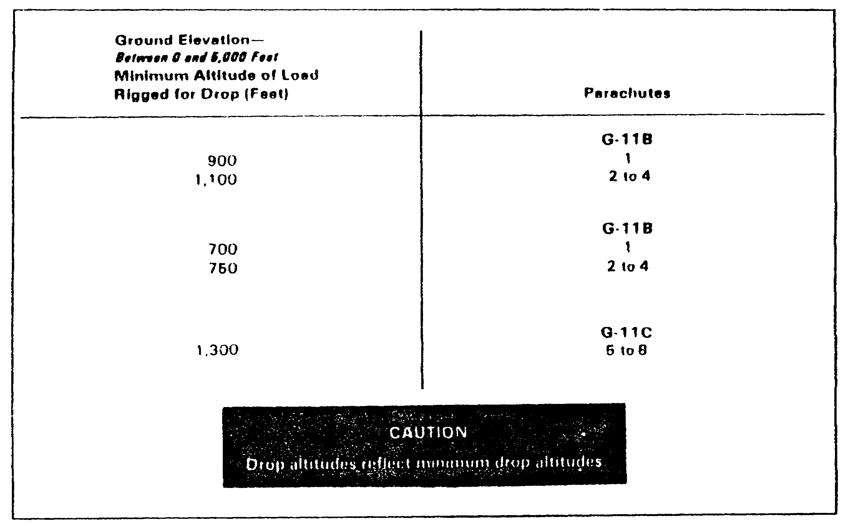

Figure 1-3. Type and number of parachutes for
low-velocity airdrop

CAUTION
Drop altitudes in Figure 1-3 reflect minimum drop altitudes

(1) Type III Nylon Cord. Use type III nylon cord (often referred to as 550 cord) to make safety ties and to hold items in place. The nylon cord has a breaking strength of 550 pounds.

(2) Webbing. Fold all excess lengths of webbing and tape or tie the excess lengths with type I, 1/4-inch cotton webbing. This reduces the danger of the containers becoming loose during their ejection or release from the aircraft.

(a) One-Half Inch Tubular Nylon Webbing. Use 1/2-inch tubular nylon webbing to secure the items during the airdrop and to tie the deadman's safety tie. This webbing has a breaking strength of 1,000 pounds.

(b) Type I, One-Quarter Inch Cotton Webbing. Use type I, 1/4-inch cotton webbing to make many of the needed safety ties. This webbing has a breaking strength of 80 pounds.

QM 3507 1-12
b. Wood Items. Make sure that all the wood items that you use to rig platform loads for airdrop are made locally. Refer to the rigging manual for details concerning how to build these wood items.

c. Miscellaneous Items. Miscellaneous items include tape, wadding, felt sheets, and honeycomb pads. The following subparagraphs describe the use of these miscellaneous items in rigging the load:

(1) Tape. Use 2-inch-wide adhesive tape (masking tape) to secure the folds in the webbing. Also use it to prevent the type III nylon cord from cutting the honeycomb and to hold padding in place. Use it for other tasks as appropriate.

NOTE: DO NOT use the tape to secure the folds of the extraction lines, the extraction slings and bridles, or the deployment lines.

(2) Cellulose Wadding and Felt Sheets. Cellulose wadding and felt sheets have many uses. Use them to pad fragile items, to prevent sharp edges from cutting, and to protect slings during airdrop.

(3) Honeycomb Pads. Honeycomb pads dissipate energy. Use them to absorb the landing shock. Also use honeycomb pads to level, pad, and fill empty spaces.

7. Determination of Other Airdrop Rigging Equipment Needed to Sustain Mission Requirements (Including Maintenance Operations).

The staff planner uses the planning factors that are shown in Figure 1-4 to determine the percentage of airdrop equipment that is used in a specific geographical area. He also uses computations, such as those that are shown in the following examples, to determine the amounts of supplies that will be airdropped by each type of equipment.

1-13 QM 3507

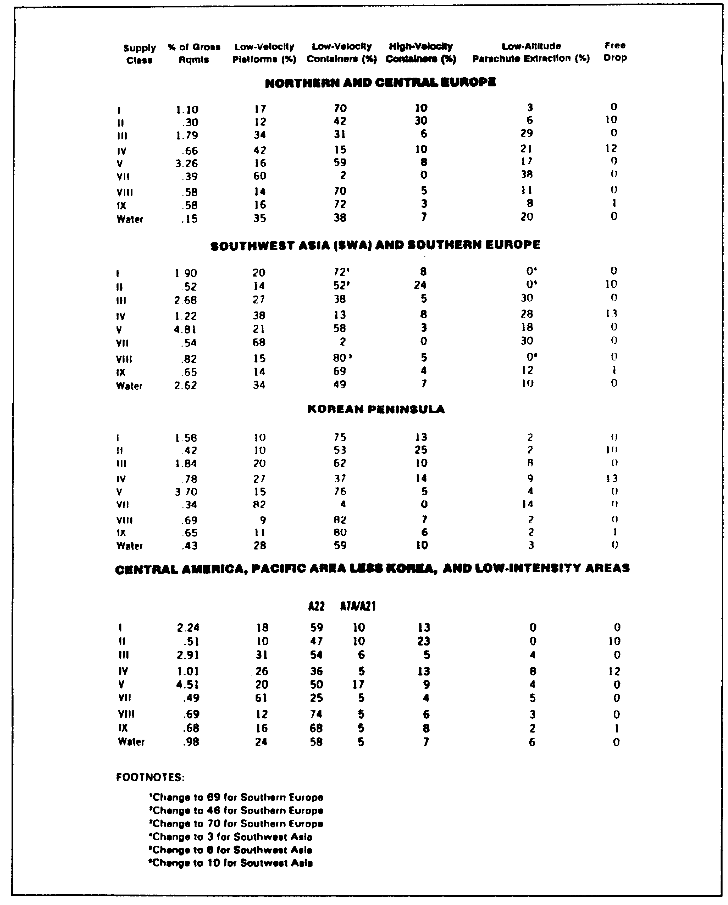

Figure 1-4. Airdrop resupply planning factors

QM 3507 1-14

a. Example 1, Computation. You are to airdrop five short tons (STONs) of Class I supplies in Germany (central Europe). Use the following procedure to compute how many pounds you will airdrop by low-velocity platforms:

- First, find the section that is headed "NORTHERN AND CENTRAL EUROPE."

- Then, in the "Supply Class" column, locate "I."

- Now, follow row "I" across to the "Low-Velocity Platforms (%) " column. The number is 17.

- Then, multiply .17 (17 percent) by 5 STONs to obtain 0.85 STON: .17 x 5 STON = 0.85 STON. You will airdrop 0.85 STON by low-velocity platforms.

b. Example 2, Computation. You are to airdrop six STONs of Class III supplies in Korea (Korean Peninsula). Use the following procedure to compute how many pounds you will airdrop by low-velocity containers:

- First, find the section that is headed "KOREAN PENINSULA."

- Then, in the "Supply Class" column, locate "III."

- Now, follow row "III" across to the "Low-Velocity Containers (%) " column. The number is 62.

- Then, multiply .62 (62 percent) by 6 STONs. The product is 3.72 STONs: .62 x 6 STONs = 3.72 STONs. You will airdrop 3.72 STONs by low-velocity containers:

8. Calculation of Quantities of Serviceable and Returnable Equipment from an Airdrop Mission.

After the airdrop is completed, you can use some of the airdrop equipment again. You may service or repair items such as platforms, containers, and parachutes. Use Figure 1-5 to estimate the quantities of the air delivery equipment that you can retrograde.

1-15 QM 3507

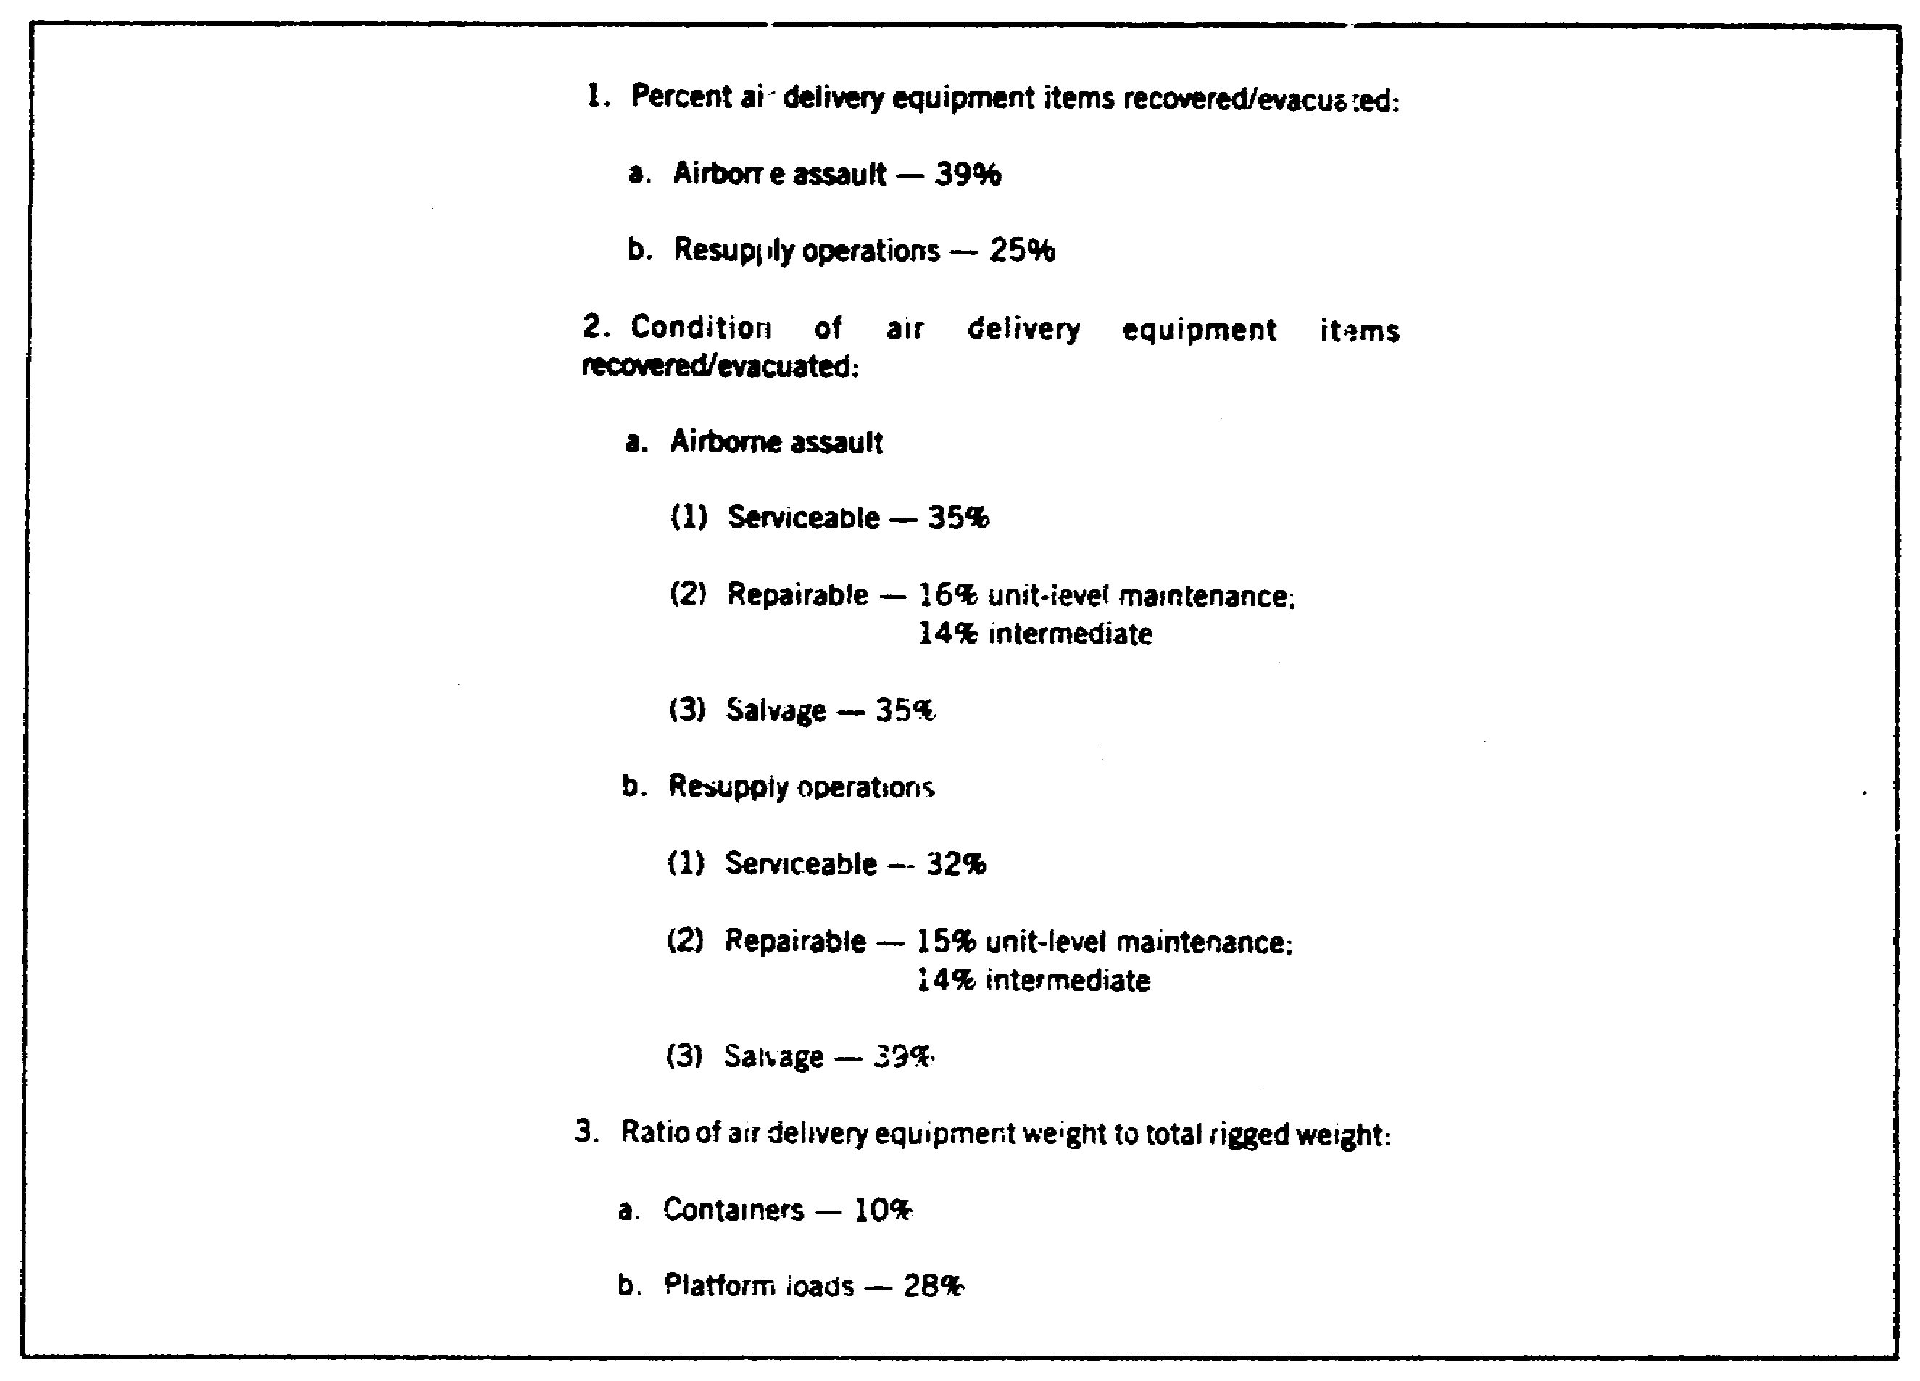

Figure 1-5. Air delivery equipment item recovery rates

For example, an airdrop uses 200 G-12D parachutes and 200 A-22 containers to resupply a ground operation. Determine the number of the serviceable, reparable, and salvageable parachutes and containers.

- First, refer to Figure 1-5, subparagraph 1b, resupply operations. The estimated percent that you can recover and evacuate is 25.

NOTE: When you use these calculations, express percent by dropping the percent sign and moving the decimal two places to the left. Therefore, 25% becomes .25.

- Then, determine the estimated number of the parachutes that you will recover and evacuate by multiplying .25 by 200 (the number of G-12D parachutes you used in the operation). You estimate that 50 parachutes will be serviceable, reparable, or salvageable.

QM 3507 1-16

- Now, refer to Figure 1-5, subparagraph 2b, resupply operations to determine the condition of the recovered and the evacuated items. The serviceable percentage is 32. The reparable percentage is 14 for intermediate repairs and 15 for unit-level maintenance. The salvageable percentage is 39.

- Then, determine the estimated number of the parachutes that will be serviceable by multiplying .32 by 50 (the number of the parachutes that you recover and evacuate, as determined previously). You estimate that 16 parachutes will be serviceable.

- Then, determine the total percentage of the parachutes that are reparable by adding the .14 that you used to determine the intermediate repairs to the .15 that you used to determine the unit-level maintenance. The total percentage is 29.

- Now, determine the number of the reparable parachutes by multiplying .29 by 50 (the number of the parachutes that you recovered and evacuated, as determined previously). The answer is 14.5. Round 14.5 down to 14 parachutes. This is your estimate of the number of the parachutes that will be reparable.

- Next, determine the number of the parachutes that you estimate to be salvageable by multiplying .39 by 50 (the same number of parachutes that you recovered and evacuated, as determined previously). The answer is 19.5. Round 19.5 down to 19 parachutes. This is your estimate of the number of parachutes that will be salvageable.

Use the same procedure to estimate the number of the containers that you will recover and excavate and to estimate the number of the containers that will be serviceable, reparable, and salvageable.

1-17 QM 3507

9. Airdrop Aircraft.

Airdrop aircraft include both US Army helicopters and USAF fixed-wing aircraft. US Army and USAF airdrop aircraft are discussed in the following subparagraphs:

CAUTION

Ensure that container loads that are to be airdropped from cargo hook(s), helicopter doors, and doors of utility aircraft are rigged with parachutes that are equipped with breakaway static lines.

a. US Army Aircraft. Use US Army aircraft for airdrop operations when special missions are conducted employing small-unit forces. The aviation supporting unit is responsible for preparing the aircraft for personnel or equipment drops.

(1) UH-1 (Iroquois) Helicopter. The UH-1 helicopter can carry supplies both internally (door loads) and externally (cargo hook loads). Responsible aviation personnel determine the allowable weight of the total cargo load from weight limitation data that are provided in TM 55-1520-210-10 (Operator's Manual for UH-1H/V Helicopters). The weight and the dimensional limits for both the door loads and the cargo hook loads are shown in Figure 1-6.

(2) UH-60 (Blackhawk) Helicopter. The UH-60 helicopter can carry supplies both internally (door loads) and externally (cargo hook loads). Responsible aviation personnel determine the allowable weight of the total cargo load from the weight limitation data that are provided in TM 55-1520-237-10 (Operator's Manual for UH-60A and EH-60A Helicopters). The weight and the dimensional limits for both the door loads and the cargo hook loads are shown in Figure 1-6.

(3) CH-47 (Chinook) Helicopter. The CH-47 helicopter can deliver supplies as ramp loads and as cargo hook loads. Responsible aviation personnel determine the weight allowance of the total cargo load from the weight limitation data that are provided in TM 55-1520-240-10 (Operator's Manual for CH-47D Helicopter). You may drop any standard A-7A cargo sling, A-21 cargo bag, or A-22 cargo bag load from the cargo ramp. Limit the maximum size of a load that you drop from the external cargo hook by the maximum dimensions of the container.

QM 3507 1-18

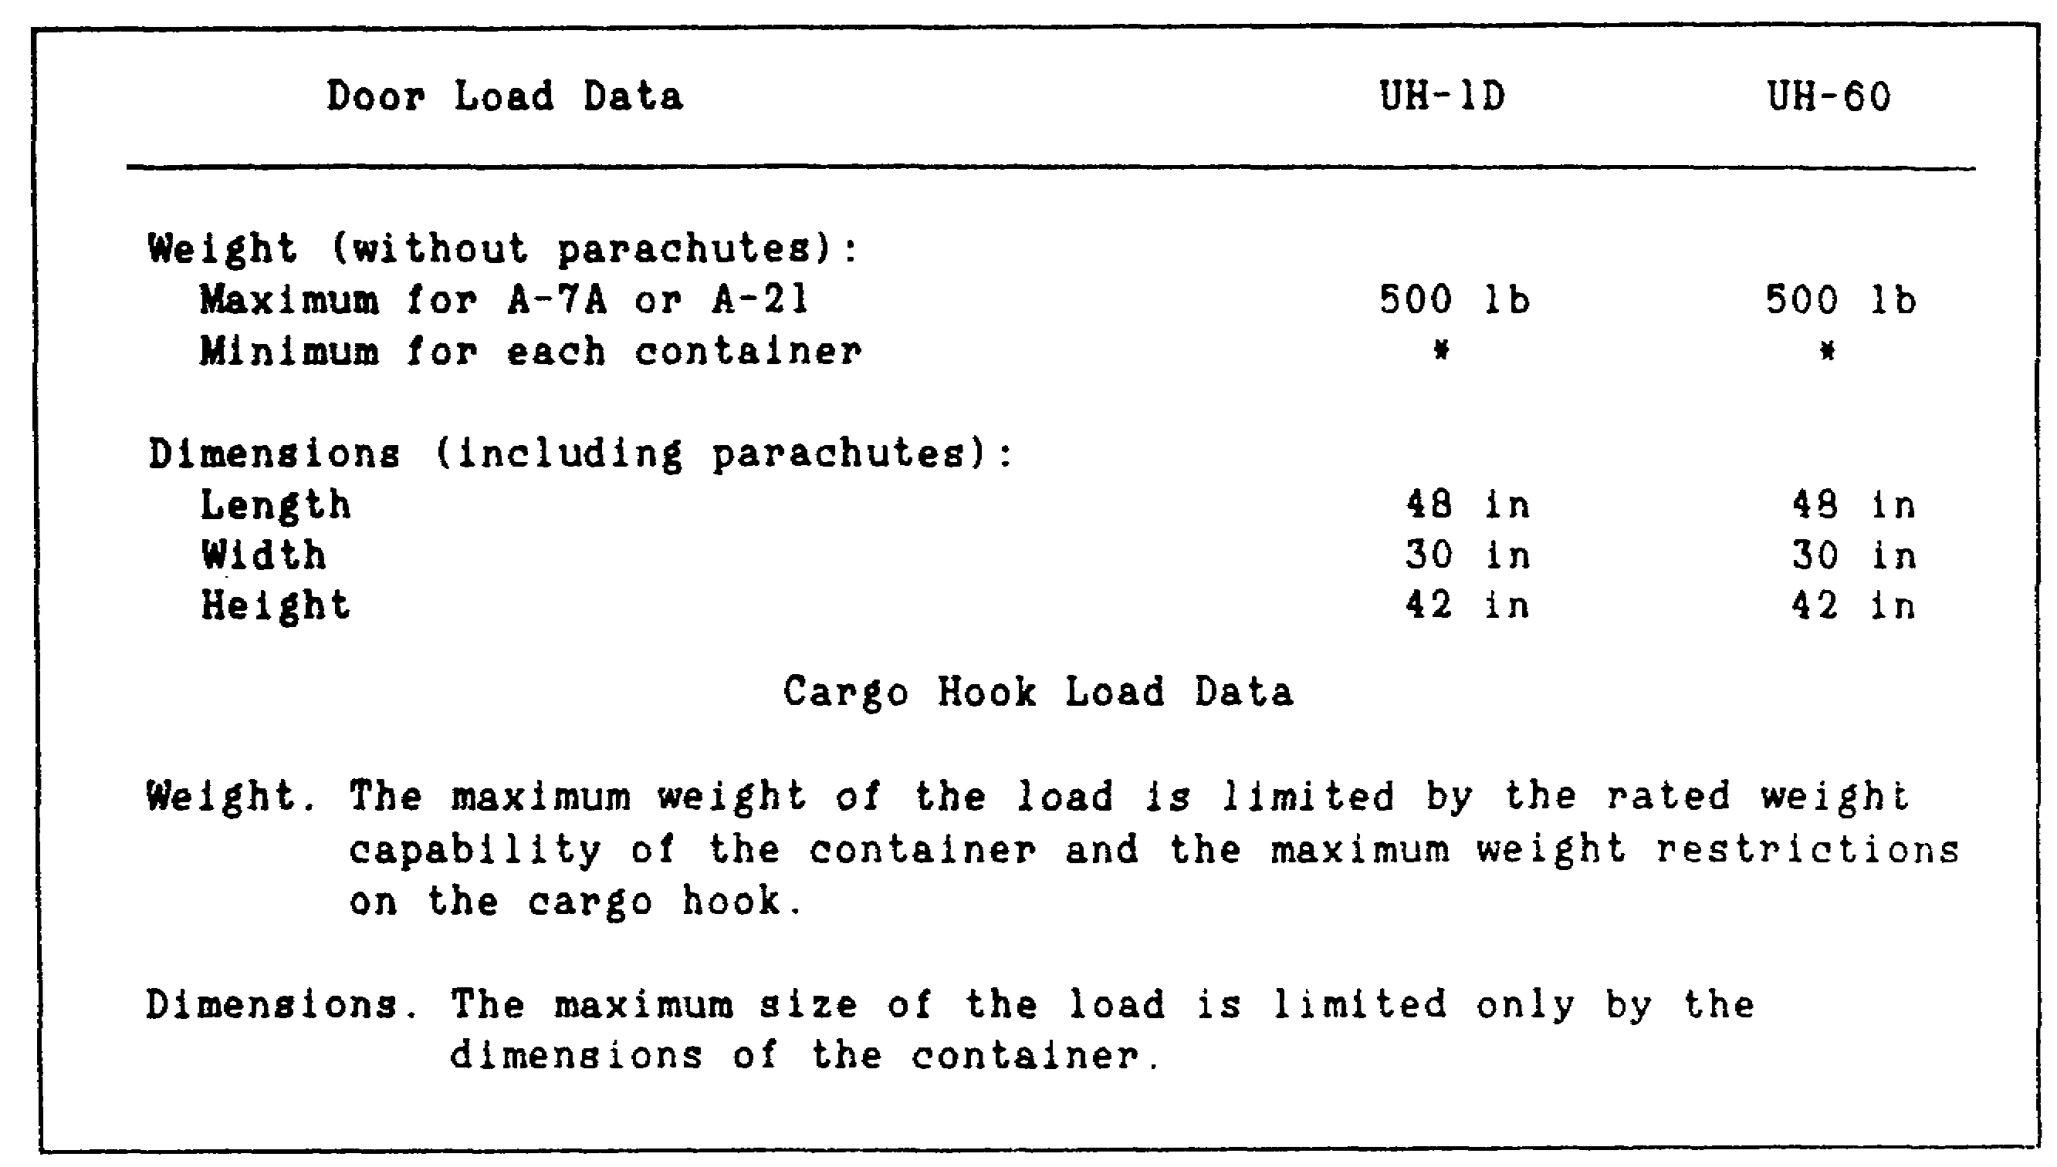

Figure 1-6. Load limitations for UH-1 and UH-60 helicopters

b. United States Air Force Aircraft. The USAF transport aircraft is configured to meet the needs of the airdrop mission. The following subparagraphs describe the aircraft loads:

(1) C-130 and C-141 Aircraft. The C-130 can carry a maximum load of 16 A22 container delivery systems (CDSs). It also carries sufficient platforms to make a maximum length of 36 feet. The C-141 can carry a maximum of 40 A22 CDSs and platforms that total a maximum of 78 feet. Both the C-130 and the C-141 aircraft can deliver container loads from the paratroop door or from the cargo ramp.

(a) Platform Loads. For the C-130 aircraft, restrict platform loads to a height of 100 inches (measured from the bottom of the platform) and a weight of 25,000 pounds for aircraft that have an aircraft serial number of 62-1783 or lower. For aircraft with an aircraft serial number of 62-184 or higher, restrict the weight to 42,000 pounds.

For the C-141 aircraft, restrict the platform loads to a height of 100 inches (measured from the bottom of the platform) and a weight of 38,500 pounds. During contingency (wartime) operations, with USAF approval, you may increase the maximum

1-19 QM 3507

platform weight to 42,000 pounds. For multiple platforms, airdrop up to 70,000 pounds.

(b) Paratroop Door Loads. The maximum weight limit for the paratroop door load is 500 pounds excluding the weight of the parachute. If a load weighs more than 350 pounds, three trained, designated pushers must help the jumpmaster push the load from the aircraft. The dimensions, including the parachute, must not exceed 48 by 30 by 66 inches. When you drop a load from the door, place the longest dimension in an upright position.

(c) Ramp Loads. Drop A-7A and A-21 loads off the ramp that is attached to a skid board. Drop A-22 containers from the cargo ramp in a single or a double stick. The number of containers dropped will vary depending on the type of the aircraft and the skid size. Refer to Figure 1-7 for aircraft CDS capabilities. The maximum height of a container must not exceed 83 inches.

(2) United States Air Force Aircraft Safety Considerations. When you airdrop container loads from USAF aircraft, apply the following considerations:

(a) General Safety. Observe the following general safety rules:

- Normally, you rig loads with parachutes that have nonbreakaway static lines.

- Make sure that loads do not weigh less than 28 pounds per square foot of the largest surface area.

(b) Paratroop Door Safety. Observe the following paratroop door safety rules:

- Use parachutes that have nonbreakaway static lines to rig loads that will be followed immediately by parachutists. Make sure that each static line has a drogue attached to it. Ensure that the drogue is used as the appropriate technical manuals require.

- Drop loads either before or after a stick of parachutists, but DO NOT intermingle loads and parachutists.

- Make sure that you place the load so that the largest dimension is upright or vertical in the door. Position the parachute on top

QM 3507 1-20

of the load or toward the inside of the aircraft.

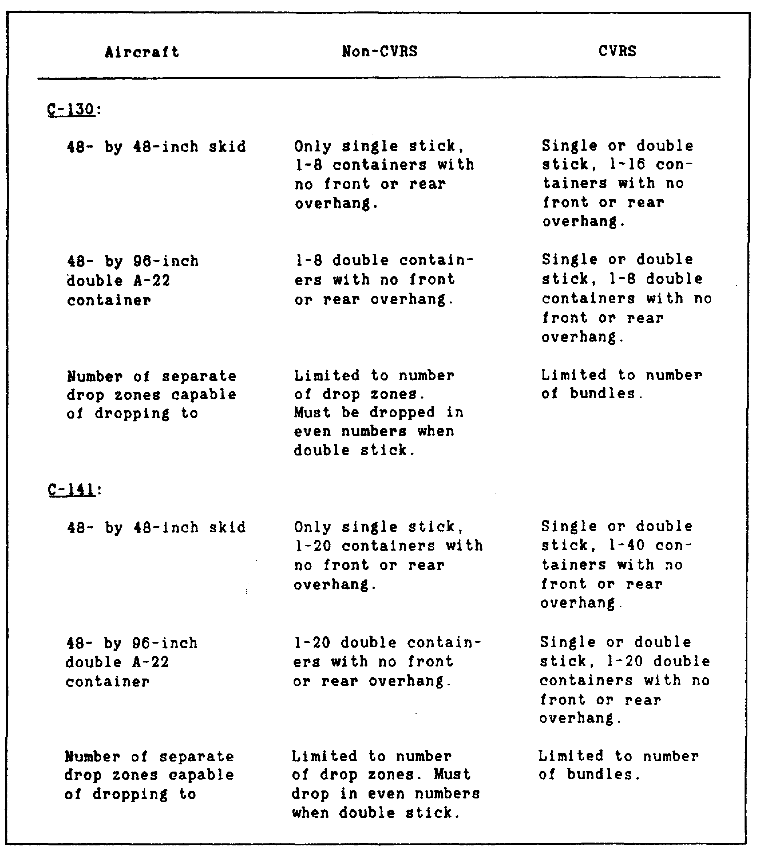

Figure 1-7. Aircraft container delivery system
capabilities

1-21 QM 3507

(c) Ramp Safety. Unless you are instructed otherwise, ensure that you rig the loads that are to be followed immediately by parachutists with parachutes that have breakaway static lines.

10. Calculation of Aerial Delivery Requirements.

Airdrop as a means of resupply exposes personnel and equipment to risks, both in peacetime and during war. Minimize this risk by employing accurate and detailed planning and by calculating estimates of the amounts of the manpower and the equipment that you need for the airdrop.

The air logistic planning sequence determines your resource requirements. Resource requirements are the type of the aircraft, the air delivery equipment, and the rigging effort. The sequence is a logical means of sequentially resolving air logistics issues that are critical to supporting the combat plan. Use the following steps in the planning sequence, paying particular attention to accuracy when you calculate steps 3 through 7.

a. Step One: Identify Task Requirements. The unit commander is responsible for identifying the task requirement. This is the most difficult step because, at the unit level, there is a lack of knowledge concerning airdrop operations. In addition, this step is difficult because units often do not know exactly what they want to drop (especially in peacetime) and they are unable to define support parameters. You often must ask the right questions to gather the required information.

For example, a supply company may request that you airdrop medical supplies for a battalion. The unit commander is responsible for identifying the requirements of this task. As such, he submits DD Form 1974 through TOC channels back to the corps. However, you can assist him by asking such questions as the following:

- How many pounds of medical supplies do you require? Does your requirement represent the maximum quantities of the supplies that you need?

- Where do you want the supplies to be dropped? What are the DZ coordinates?

- When do you want the supplies to be dropped?

- You want the supplies to be dropped in what type of terrain?

- How many personnel do you have available to pick up the supplies?

QM 3507 1-22

- What type, and how many, transport vehicles do you have available to pick up the supplies?

For example, a battalion requires a maximum of 1,030 pounds of medical supplies. The plan is to drop these supplies at 0800 on 21 Apr XX on flat terrain. The location of the DZ is approximately 830 nautical miles from your position. The coordinates are defined in eight digits from the center of the DZ. The requesting unit has 844 personnel. Two vehicles are available to pick up the supplies.

b. Step Two: Convert Task Requirements to Airdrop Requirements. This step is difficult due to a lack of publications. It also is difficult because existing information is scattered throughout various publications. During step two, use airdrop planning data (obtained in the subsequent steps) to convert the tonnages and the quantities of resupply into a specific number of A-22 CDSs and platform loads.

c. Step Three: Calculate the Number of Sorties. A sortie is one flight by one aircraft. The number of flights depends on the capacity of the aircraft and the quantity of the supplies and the equipment that you are to deliver.

(1) Task Information. Task information is the specific data that you require to perform the calculation. The following bullets describe the information that you require for this calculation:

- Determine the number of the items, such as personnel, A22s, and platforms, that you need to deliver.

- Determine the logistic capacity of the aircraft that you are to use for the type of the airdrop that is required.

(2) Calculations. Determine the number of the sorties that must be made. Determine the task information as follows:

- Determine the number of items that you are to deliver. Divide this number by the logistic capacity of the aircraft. If a decimal fraction is present, round up.

- The quotient from the preceding bullet is the number of sorties required.

1-23 QM 3507

(3) Example one: Calculate the Number of Sorties Needed to Deliver A-22s. You work in operations and are assigned the task of determining the number of the sorties that are required to airdrop 127 A-22s using a C-130 aircraft. A C-130 can carry 16 A-22s per sortie. To determine the number of the sorties that are required, use the following procedure:

- First, divide the number of A-22s that you need for the airdrop requirement by the number of the A-22s that the aircraft can carry:

127 divided by 16 equals 7.94. Round 7.94 up to 8.

- The C-130 must make 8 sorties to airdrop the 127 A-22s.

(4) Example Two: Calculate the Number of Sorties Needed to Deliver Platforms. You work in operations and are assigned the task of determining the number of the sorties that are required to airdrop thirteen 8-foot platforms using a C-141 aircraft. Each platform weighs 3,200 pounds. The maximum length of platforms that the C-141 can carry is 78 feet. The maximum allowable cargo load (ACL) is 90,200 pounds.

To determine the number of the sorties that are required, use the following procedure:

- First, divide the maximum length of the platforms that the C-141 can carry by the length of each platform.

- Then, divide the number of the platforms for the airdrop requirement by the quotient from the preceding bullet:

13 divided by 9 equals 1.44. Round the number up to 2.

- Two sorties are required to deliver thirteen 8-foot platforms.

(5) Example Three: Calculate the Number of Sorties Needed to Deliver Personnel. You work in operations and are assigned the task of determining the number of sorties that are required to airdrop 465 paratroopers using a C-141 aircraft. The C-141 can carry a maximum of 152 paratroopers per sortie.

QM 3507 1-24

- First, divide the number of the paratroopers who are to be delivered by the number of the paratroopers whom the C-141 can carry per sortie:

465 divided by 152 equals 3.06. Round up to 4.

- Four sorties are required to deliver the 465 paratroopers.

d. Step Four: Calculate the Sortie Time. Calculate sortie time for the airdrop sequence from the first sortie take off until the aircraft is ready to take off on the next sortie.

(1) Task Information. You require the following information to calculate the sortie time:

- Time in the air.
- Time in the DZ.
- Turnaround time.
- Aircraft speed.

The following four bullets discuss sortie time:

- The time in the air includes the time that it takes to travel the distance to the destination (outbound) and to travel the return distance from destination (inbound). The outbound leg may be a different distance than the return leg because of a deception plan or because of air-to-air refueling. Another difference may result from avoiding nonfriendly counties, shipping lanes, or other areas that may compromise the secrecy or the security of the airdrop.

- The time in the DZ allows for slowing, formation changes, and DZ approaches and escape routes.

- The turnaround time is the time that it takes from when the aircraft returns from a sortie to when it is taking off for the next sortie. This time includes loading, refueling, maintenance (routine and combat repair), crew change, briefing and debriefing, and flight planning.

- Aircraft speed is the planning speed of the aircraft that is required for the calculation. For example, a C-130 planning speed is 280 nautical miles per hour (knots).

1-25 QM 3507

(2) Calculations. Use the following procedure to determine sortie time:

- First, determine the time that it takes to fly the outbound leg by dividing the distance by the planning speed of the aircraft.

- Then, determine the time that it takes to fly the return leg by dividing the distance by the planning speed of the aircraft.

- Next, add the turnaround time to the time in the DZ.

- Then, add the results that you obtained by performing the actions described in the preceding three bullets to find the sortie time.

(3) Example: Calculate Sortie Time. You work in operations and are assigned the task of determining the sortie time that is required to perform an airdrop using a C-141 aircraft. The outbound leg is 850 nautical miles (nm). The return leg is 700 nm. The time at the DZ will be 15 minutes. The turnaround time is 2.6 hours. The planning speed of a C-141 is 425 nm per hour (knots). Perform the calculations for the C-130 aircraft in the same manner as for C-130-specific information.

- First, divide the outbound leg time of 850 nm by 425 knots to obtain 2 hours.

- Then, divide the inbound leg time of 700 nm by 425 knots to obtain 1.65 hours.

- Then, add the turnaround time of 2.60 hours to the time in the DZ, which is 0.25 hour, to obtain 2.85 hours.

- Add 2.00 hours, 1.65 hours, and 2.85 hours together to obtain the total sortie time of 6.50 hours.

e. Step Five: Calculate the Minimum Number of Aircraft. Aircraft allocation and tasking is the most important issue in the airdrop planning (ADP) sequence. Perform this calculation to put dimensions on the task.

(1) Task Information. Use the time that is available and the sortie time to calculate the minimum number of aircraft.

QM 3507 1-26

- The time that is available is the time that you need to accomplish the airdrop.

- The sortie time is the time that it takes for an aircraft to complete one sortie.

(2) Calculations. Determine the minimum number of aircraft as follows:

- First, divide the time that is available by the sortie time.

- Then, divide the number of the sorties by the integer portion of the quotient that you obtained in the first step.

- The quotient from the preceding bullet represents the number of the aircraft. If a decimal quotient is present, round the number up.

(3) Example One: Calculation of the Minimum Number of Aircraft. You work in operations and are assigned the task of determining the minimum number of the aircraft that are required to deliver some items to a DZ. Twenty-eight sorties are required. The time available is 30 hours. The sortie time is 8.4 hours.

- First, divide the time that is available by sortie time:

30 hours divided by 8.4 hours = 3.57. The integer portion of 3.57 is 3.

- Then, divide the number of sorties (28) by 3 (the integer portion of 3.57, obtained in the preceding step). The answer is 9.33. Round up to 10.

- The minimum number of aircraft is 10.

f. Step Six: Calculate Airdrop Equipment Requirement. This calculation ensures that you have adequate equipment for the required airdrop. The absence of one piece of airdrop equipment (ADE) can cause a mission failure.

(1) Task Information. The airdrop officers ensure that there is a detailed ADE requirement calculation for each task. Figure 1-8 is an example of the equipment that is required to airdrop one high-mobility multipurpose wheeled vehicle (HMMWV). Figure 1-9 shows an example of the equipment that is required to rig two or more items.

1-27 QM 3507

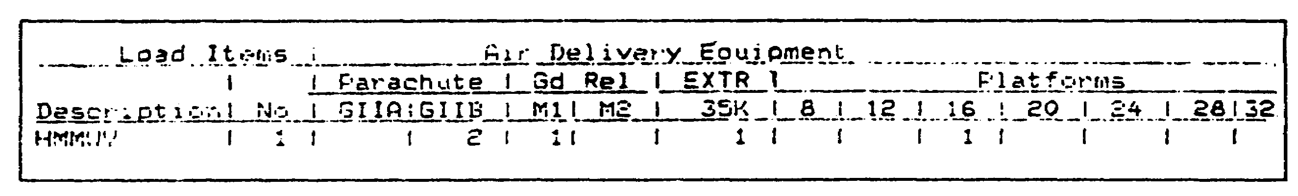

Figure 1-8. Airdrop equipment requirements for one HMMWV

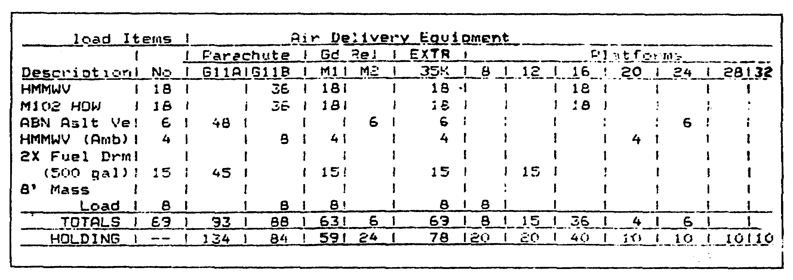

Figure 1-9. Airdrop equipment for multiple airdrop

(2) Calculations. After you calculate the requirements, compare the totals with the equipment that is in stock. This calculation determines the equipment that you require and the balance of the equipment that remains in stock after the airdrop.

(3) Example Airdrop Equipment Calculations. In Figure 1-9, the row that is labeled "TOTALS" shows the ADE that you require for a rigging-specific airdrop. The row that is labeled "HOLDING" shows the ADE that is currently in stock. When the number in the "TOTALS" row is greater than the number in the "HOLDING" row, you require additional equipment to accomplish the airdrop. Refer to Figure 1-9 and determine the requirements for ADE.

- You require 93 G11A parachutes to rig the airdrop. You are holding 134 in stock. Forty-one remain in stock after you rig the airdrop.

- You require 88 G11B parachutes to rig the airdrop. You are holding 84 in stock. You need four more to complete the rigging.

QM 3507 1-28

- You require 63 M1 ground releases to rig the airdrop. You are holding 59 in stock. You need four more to complete the rigging.

- You require six M2 ground releases to rig the airdrop. You are holding 24 in stock. Eighteen remain in stock after you rig the airdrop.

- You require 69 35K EXTRs to rig the airdrop. You are holding 78 in stock. Nine remain in stock after you rig the airdrop.

- You require eight 8-foot platforms to rig the airdrop. You are holding 20 in stock. Twelve remain in stock after you rig the airdrop.

- You require fifteen 12-foot platforms to rig the airdrop. You are holding 20 in stock. Five remain in stock after you rig the airdrop.

- You require thirty-six 16-foot platforms to rig the airdrop. You are holding 40 in stock. Four remain in stock after you rig the airdrop.

- You require four 20-foot platforms to rig the airdrop. You are holding 10 in stock. Six remain in stock after you rig the airdrop.

- You require six 24-foot platforms to rig the airdrop. You are holding 10 in stock. Four remain in stock after you rig the airdrop.

- You do not require any 28- or 32-foot platforms to rig the airdrop. You are holding 10 of each platform in stock.

g. Step Seven: Estimate the Rigging Effort. Estimating the rigging effort is neither scientific nor exact due to the number of variables that influence the rigging time and the manpower requirements. You may estimate the quantity of the manpower that you require, given the time that is available. Alternatively, you may estimate the time that you require, given the manpower that is available.

(1) Task Information. You need the following data to calculate the estimated rigging effort:

- Number of items to be rigged.
- Time needed to rig the first item.
- Time needed to rig each subsequent item.

1-29 QM 3507

(2) Calculations of Rigging Time for A22 CDS (Man-Days). The following steps are used to calculate the man-days of effort that are needed for the A22 CDS.

- First, determine the number of the A22 CDSs that you need to rig.

- Then, divide the number of the A22 CDSs that you need to rig by the number of the man-days that you need to rig one A22 CDS.

- The quotient that you obtain from the division that you performed in the previous bullet is the number of the man-days of effort.

(3) Example: Estimating Rigging Effort for A22 CDS (Man-Days). You work in operations and are assigned the task of estimating the man-days that are required to rig 42 105-millimeter (mm) howitzers, 67 81-mm mortars, and 138 cases of MRE, combat, individual (MCI) on the A22 CDSs.

You require 2.1 man-days to rig the first 105-mm howitzer on the A22 CDS.

You need 1.8 man-days to rig the first 81-mm mortar on the A22 CDS.

You need 2.7 man-days to rig the first MCI on the A22 CDS.

- First, divide the number of the 105-mm howitzers by the man-days that you require to rig one 105-mm howitzer A22 CDS:

42 A22s for howitzers divided by 2.1 man-days = 20.0 man-days.

- Then, divide the number of the 81-mm mortars by the man-days that you require to rig the first 81-mm mortar on the A22 CDS:

67 81-mm mortars divided by 1.8 man-days = 37.2 man-days.

- Next, divide the number of the A22 CDSs that contain MCIs by the output time of one A22 CDS of MCIs:

138 MCI A22s divided by 2.7 man-days = 51.1 man-days.

QM 3507 1-30

- Now, add the answers that you obtained by performing the actions that are described in the to the preceding three bullets to find the total man-days:

20 man-days + 37.2 man-days + 51.1 man-days = 108.3 man-days.

(4) Calculation of Rigging Time for Platforms (Man Hours). Use the following steps to calculate the hours of effort that you require to rig the platforms:

- First, determine the number of the platforms that you must rig.

- Then, multiply one platform load by the time that it takes you to rig the first platform.

- Next, multiply the remaining platform loads (the number of platforms minus one) by the time that it takes you to rig the subsequent platforms.

- Now, add the product that you obtained by the multiplication that you performed in the second bullet to the product that you obtained by performing the action that is described in the third bullet. The sum is the total time that you estimate will be required to rig all the platforms.

(5) Example: Estimating Rigging Effort for Platforms (Hours). You work in operations and are assigned the task of estimating the hours that are required to rig 36 HMMWVs, eighteen 105-mm howitzers, and 12 Sheridan tanks for an airdrop.

You need 1.6 hours to rig the first HMMWV. The subsequent HMMWVs will take 0.5 hour each to rig.

- First, calculate the number of the hours that you need to rig the platforms for HMMWVs by multiplying the first HMMWV by the time that it takes you to rig the first:

1 HMMWV x 1.6 hours = 1.6 hours.

1-31 QM 3507

- Then, find the time that you require to rig the remaining HMMWVs by subtracting 1 from the total number of HMMWVs. Multiply the remaining HMMWVs by the time: (0.5 hour) that it takes you to rig each of the! subsequent HMMWVs:

36 HMMWV - 1 HMMWV = 35 HMMWVs.

35 HMMWV x 0.5 hour = 17.5 hours.

- The total hours that you need to rig the HMMWV's is equal to the product that you obtained by performing the multiplication in the first bullet and the pro(duct that you obtained as a result of the multiplication that you performed in the second bullet:

1.6 hours + 17.5 hours = 19.1 hours.

You require 1.1 hours to rig the first 105-mm howitzer. You need 0.4 hour to rig each of the subsequent 105-mm howitzers.

- First, calculate the number of the hours that you need to rig tile platforms for the 105-mm howitzers by multiplying the time that it takes you to rig the first 105-mm howitzer by one 105-mm howitzer:

1 105-mm howitzer x 1.1 hours = 1.1 hours.

- Second, find the time that you require to rig the remaining 105-mm howitzers by subtracting 1 from the number of the 105-mm howitzers. Multiply the remaining number 105-mm howitzers by the time (0.4 hour) that you need to rig each of the subsequent 105-mm howitzers:

eighteen 105-mm howitzers - 1 105-mm howitzer = seventeen 105-mm howitzers:

seventeen 105-mm howitzers x 0.4 hour = 6.8 hours.

- Third, the total hours that you require to rig the 105-mm howitzers is the product that you obtained by performing the multiplication in the first bullet added to the product that you obtained by performing the multiplication in the second bullet.:

1.1 hours + 6.8 hours = 7.9 hours.

QM 3507 1-32

It takes 1.7 hours to rig the first Sheridan tank. It takes 0.6 hour to rig each of the subsequent Sheridan tanks.

- First, calculate the number of the hours that you need to rig the platforms for the Sheridan tanks by multiplying the one Sheridan tank by the time that it takes you to rig the first:

1 Sheridan tank x 1.7 hours = 1.7 hours.

- Second, find the time that you require to rig the remaining Sheridan tanks by subtracting 1 from the total number of Sheridan tanks. Multiply the remaining number of tanks by the time (0.6 hour) that it takes you to rig the subsequent Sheridan tanks:

12 Sheridan tanks - 1 Sheridan tank = 11 Sheridan tanks.

11 Sheridan tanks x 0.6 hour = 6.6 hours.

- Third, the total time that you need to rig the Sheridan tanks is the product from the first bullet plus the product from the second bullet:

1.7 hours + 6.6 hours = 8.3 hours.

Your total estimate for the rigging effort equals the sum of the total hours that you require to rig each item. Add the sums from the three calculations:

19.1 hours + 7.9 hours + 8.3 hours = 35.3 hours.

h. Step Eight: Determine Trade-Offs. To determining trade-offs, you must resolve the unworkable requirements in the previous seven steps. The trade-offs require you to identify alternatives that result in risks. The trade-offs often result in the need to recompute steps one through seven.

i. Step Nine: Implement the Plan. An airdrop plan is similar to any other plan in which successful implementation requires a full commitment of resources without reservation. The number of the elements that are involved and the diverse chains of command require clear and concise coordination. Continued coordination between the chains of command is required to ensure the success of the mission.

1-33 QM 3507

11. Calculation of the Quantity of Cargo Parachutes Needed.

Platform airdrops are low-velocity and LAPE. Container airdrops are low-velocity and high-velocity. The following subparagraphs describe how to calculate platform and container airdrops.

a. Platforms. Use airdrop platforms to support the load during extraction and parachute deployment. The following subparagraphs discuss the low-velocity platform airdrop and provide examples of the calculations to use to determine the correct number of the parachutes to use for specific equipment.

(1) Low-Velocity Platform Airdrop. Use cargo parachutes to slow the descent of a low-velocity platform load. Figure 1-10 lists the weight limitations for the cargo parachutes that are used with airdrop platform loads. DO NOT use cargo parachutes on LAPE loads.

(a) Example One: Calculation of Quantity of Cargo Parachutes for Low-Velocity Platform Airdrop. The following example shows how to determine the number of the parachutes that you require for a low-velocity airdrop of a D-6 tractor that weighs 18,800 pounds. In this example, only G-11B cargo parachutes are used.

- First, refer to Figure 1-10. Find the weight range in the G-11B section of the "SUSPENDED WEIGHT IN POUNDS" column in which 18,800 pounds appear. Follow this row to the left, to the "Parachutes" column.

- The number of G-11B parachutes that is shown is four. Therefore, you require four G-11B parachutes for the low-velocity airdrop of the D-6 tractor.

(b) Example Two: Calculation of Quantity of Cargo Parachutes for Low-Velocity Platform Airdrop. The following example shows how to determine the number of the parachutes that you need for a low-velocity airdrop of a M561, 1 1/4-ton cargo truck (You will need the appropriate FM to rig). The truck weighs 8,920 pounds. In this example, only G-11B cargo parachutes are used.

- First, refer to Figure 1-10. Find which weight range in the G-11B section of the "SUSPENDED WEIGHT IN POUNDS" column contains the weight range into which the 8,920 pounds appear. Follow this row to the left, to the "Parachutes" column.

QM 3507 1-34

- The number of G-11B parachutes that is shown is two. Therefore, you need two G-11B parachutes for the low-velocity airdrop of the M56, 1 1/4-ton cargo truck.

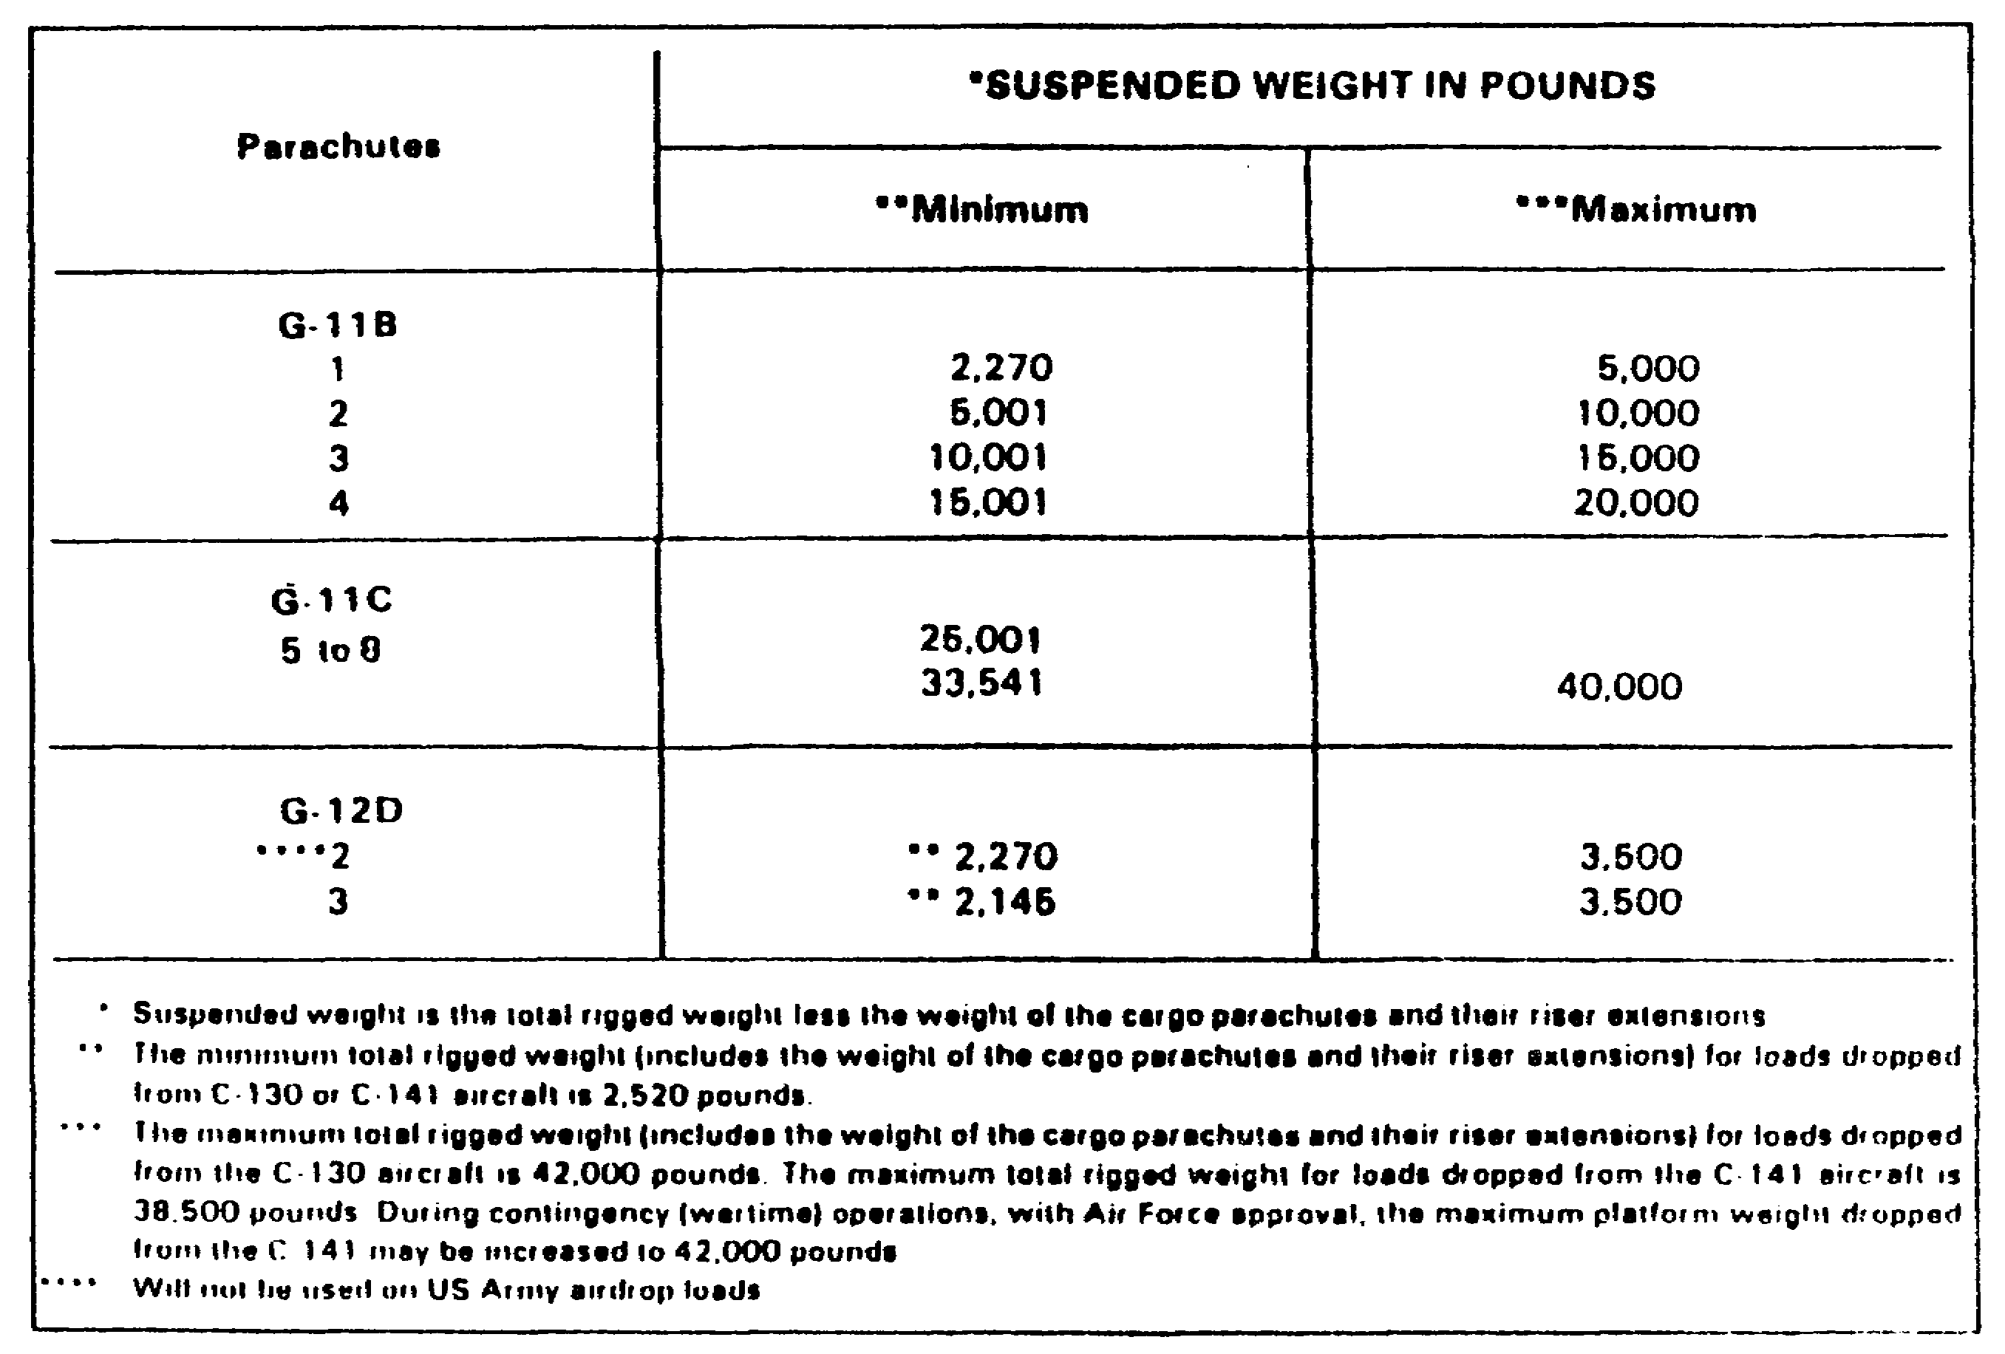

Figure 1-10. General weight limitations for cargo parachutes

(2) Low-Altitude Platform Parachute Extraction. Place a cargo extraction parachute on every low-velocity or LAPE airdrop platform load. USAF personnel hook up the parachute after the load is in the aircraft. Refer to Figure 1-11 for the extracted load range for each type of extraction parachute. The following subparagraphs describe the extraction parachutes:

(a) Types of Extraction Parachutes. Use Figure 1-11 to determine the cargo extraction parachute that you need for a LAPE airdrop platform load. The 28-foot and the 35-foot parachutes are discussed.

- The 28-foot, heavy-duty extraction parachute has a 28-foot-diameter, flat, circular ring-

1-35 QM 3507

slot nylon canopy. When you use this parachute on a LAPE airdrop platform load, pack it for the LAPE airdrop.

NOTE: The extraction force transfer coupling (EFTC) is the only extraction system that is used with the 28-foot heavy duty parachute.

- The 35-foot cargo extraction parachute has a 35-foot-diameter, flat, circular ring-slot nylon canopy. Use this parachute in the LAPE airdrop.

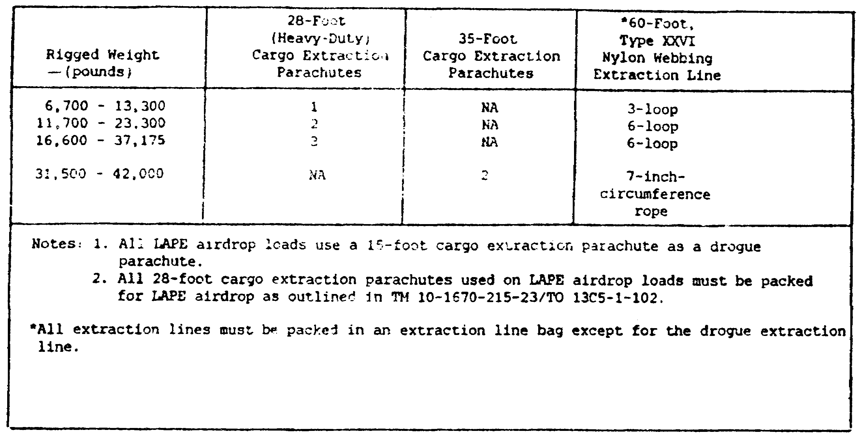

Figure 1-11. Extraction parachute requirements
for LAPE airdrop

(b) Example: Calculation of Quantity of Cargo Parachutes for Extraction Platform Airdrop. The following example shows how to determine the number of parachutes that you need for an LAPE airdrop of an M102 howitzer that weighs 8,820 pounds. This delivery will be made by a C-130 aircraft.

- First, refer to Figure 1-11 and locate "C-130 AIRCRAFT" column. Then, find the subheading "Extracted Load Range (pounds)." Locate the range in which 8,820 pounds falls. Follow this row to the right, to

QM 3507 1-36

the subheading "Cargo Extraction Parachute." The number that is shown is 22 feet.

- You require a 22-foot cargo extraction parachute for the LAPE airdrop.

b. Containers. Container loads are loads that are rigged for airdrop in airdrop containers such as the following:

- A-7A airdrop cargo sling assembly.
- A-21 cargo bag assembly.
- A-22 cargo bag assembly.
- A-23 cargo bag assembly.

Pack these containers with supplies, disassembled equipment, or small items of ready-to-use equipment that are prepared for airdrop. Cushion the loads with honeycomb, felt, or cellulose wadding depending on the load requirements and the method of the airdrop. The number and the types of the parachutes that you need to stabilize the load and to slow its descent depend on the type of the container that you use, the weight of the load, and the type of the airdrop.

(1) Low-Velocity. Use the 68-inch pilot, the G-13, and the G-14 cargo parachutes singly with A-7A cargo sling loads and A-21 cargo bag loads that are rigged for low-velocity airdrop. You also may use three 68-inch pilot parachutes on A-7A cargo sling loads. Use the G-13 or G-14 in clusters of two or three parachutes or use a G-12 cargo parachute with A-22 cargo bag loads. Refer to Figure 1-12 for a list of the minimum required weight and the maximum allowable weight for cargo parachutes that are used on loads that are rigged for low-velocity airdrops.

(a) Example One: Quantity of Cargo Parachutes Needed for a Low-Velocity Airdrop. An A-7A container of medical supplies that weighs 497 pounds is to be low-velocity airdropped. How many and what type of cargo parachutes do you require?

- First, refer to Figure 1-12. In the "Low-Velocity" section that appears under the "Suspended Weight" column, find the row that contains the weight range that includes 497 pounds. Follow this row to the left, to the "Parachutes" column.

- One G-13 or one G-14 cargo parachute is shown in the "Parachutes" column.

1-37 QM 3507

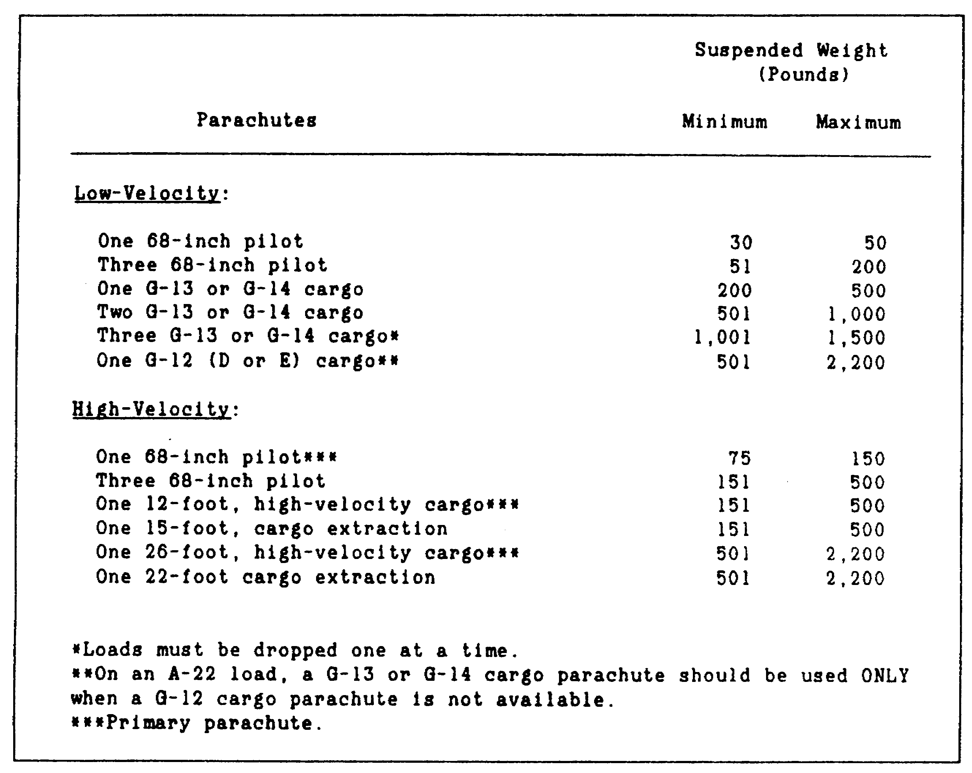

Figure 1-12. Parachute requirements

(b) Example Two: Quantity of Cargo Parachutes Needed for a Low-Velocity Airdrop. An A-22 container of fragile items that weighs 2,100 pounds is to be low-velocity airdropped. How many, and what type of, cargo parachutes do you require?

- First, refer to Figure 1-12. In the "Low-Velocity" section that appears under the "Suspended Weight" column, find the row that contains the weight range that includes 2,100 pounds. Follow this row to the left, to the "Parachutes" column.

- The "Parachutes" column shows one G-12 (D or E) cargo parachute.

QM 3507 1-38

(2) High-Velocity. A 68-inch pilot parachute is the primary parachute that is used for a 75- to 150-pound load, excluding the weight of the parachute. For loads that are more than 150 pounds, use the 12- or the 26-foot, high-velocity cargo parachute as the primary parachute whenever it is available. Refer to Figure 1-12 for the parachute's weight ranges.

If a 12-foot high-velocity cargo parachute is not available, use a 15-foot cargo extraction parachute that is packed specifically for use as a high-velocity parachute.

If a 26-foot, high-velocity cargo parachute is not available, use a 22-foot cargo extraction parachute that is packed specifically for use as a high-velocity parachute.

Special packing procedures for the 15- and the 22-foot cargo extraction parachutes consist of attaching the static lines and replacing the extraction line with a 20-foot cargo sling.

(a) Example One: Quantity of Cargo Parachutes Needed for a High-Velocity Airdrop. An A-7A container of clothing that weighs 497 pounds is to be high-velocity airdropped. How many, and what type of, cargo parachutes do you require?

- First, refer to Figure 1-12. In the "High-Velocity" section that appears under the "Suspended Weight" column, find the row with the range of weight that includes 497 pounds. Follow this row to the left, to the "Parachutes" column.

- The "Parachutes" column shows one 12-foot high-velocity cargo parachute.

(b) Example Two: Quantity of Cargo Parachutes Needed for a High-Velocity Airdrop. An A-22 container of clothing that weighs 2,100 pounds is to be high-velocity airdropped. How many, and what type of, cargo parachutes do you need?

- First, refer to Figure 1-12. In the "High-Velocity" section under the "Suspended Weight" column, find the row with the weight range that includes 2,100 pounds. Follow this row to the left, to the "Parachutes" column.

- The "Parachutes" column shows one 26-foot, high-velocity cargo parachute.

1-39 QM 3507

(c) Example Three: Quantity of Cargo Parachutes Needed for a Low-Velocity Airdrop. An A-22 container of clothing that weighs 1,375 pounds is to be high-velocity airdropped. No 26-foot, high-velocity parachutes are available. How many, and what type of, cargo parachutes do you need?

Refer to subparagraph 11(2) of Part I of this subcourse. If a 26-foot, high-velocity cargo parachute is not available, use a 22-foot cargo extraction parachute that is packed specifically for use as a high-velocity parachute.

PART B - DROP ZONE COORDINATION PROCEDURES

1. Drop Zone Selection.

A DZ is any designated area in which the delivery of personnel and equipment by parachute or free drop takes place. The DZ is located where it can support the ground tactical plan. The DZ is selected by the ground-unit commander. For tactical training, the ground-unit commander checks the USAF assault zones availability report (AZAR) for an approved DZ within the tactical area.

a. Drop Zone Size Criteria. The following are responsible jointly for ensuring that the DZ size and selection criteria are

- Commander, Airlift Forces (COMALF).

- Commander, Air Force Special Operation Forces (COMAFSOF).

- Air component commander (ACC).

- Supported force commander.

During tactical airdrop missions in which personnel or equipment are dropped, the minimum DZ sizes that are shown in Figure 1-13 apply. The minimum DZ sizes for HAARS and high-velocity CDS are shown in Figure 1-14.

The following subparagraphs describe the normal minimum training DZ sizes. For other than USAF unilateral airdrops, the ground commander or user may waive these minimums on a "by exception" basis.

QM 3507 1-40

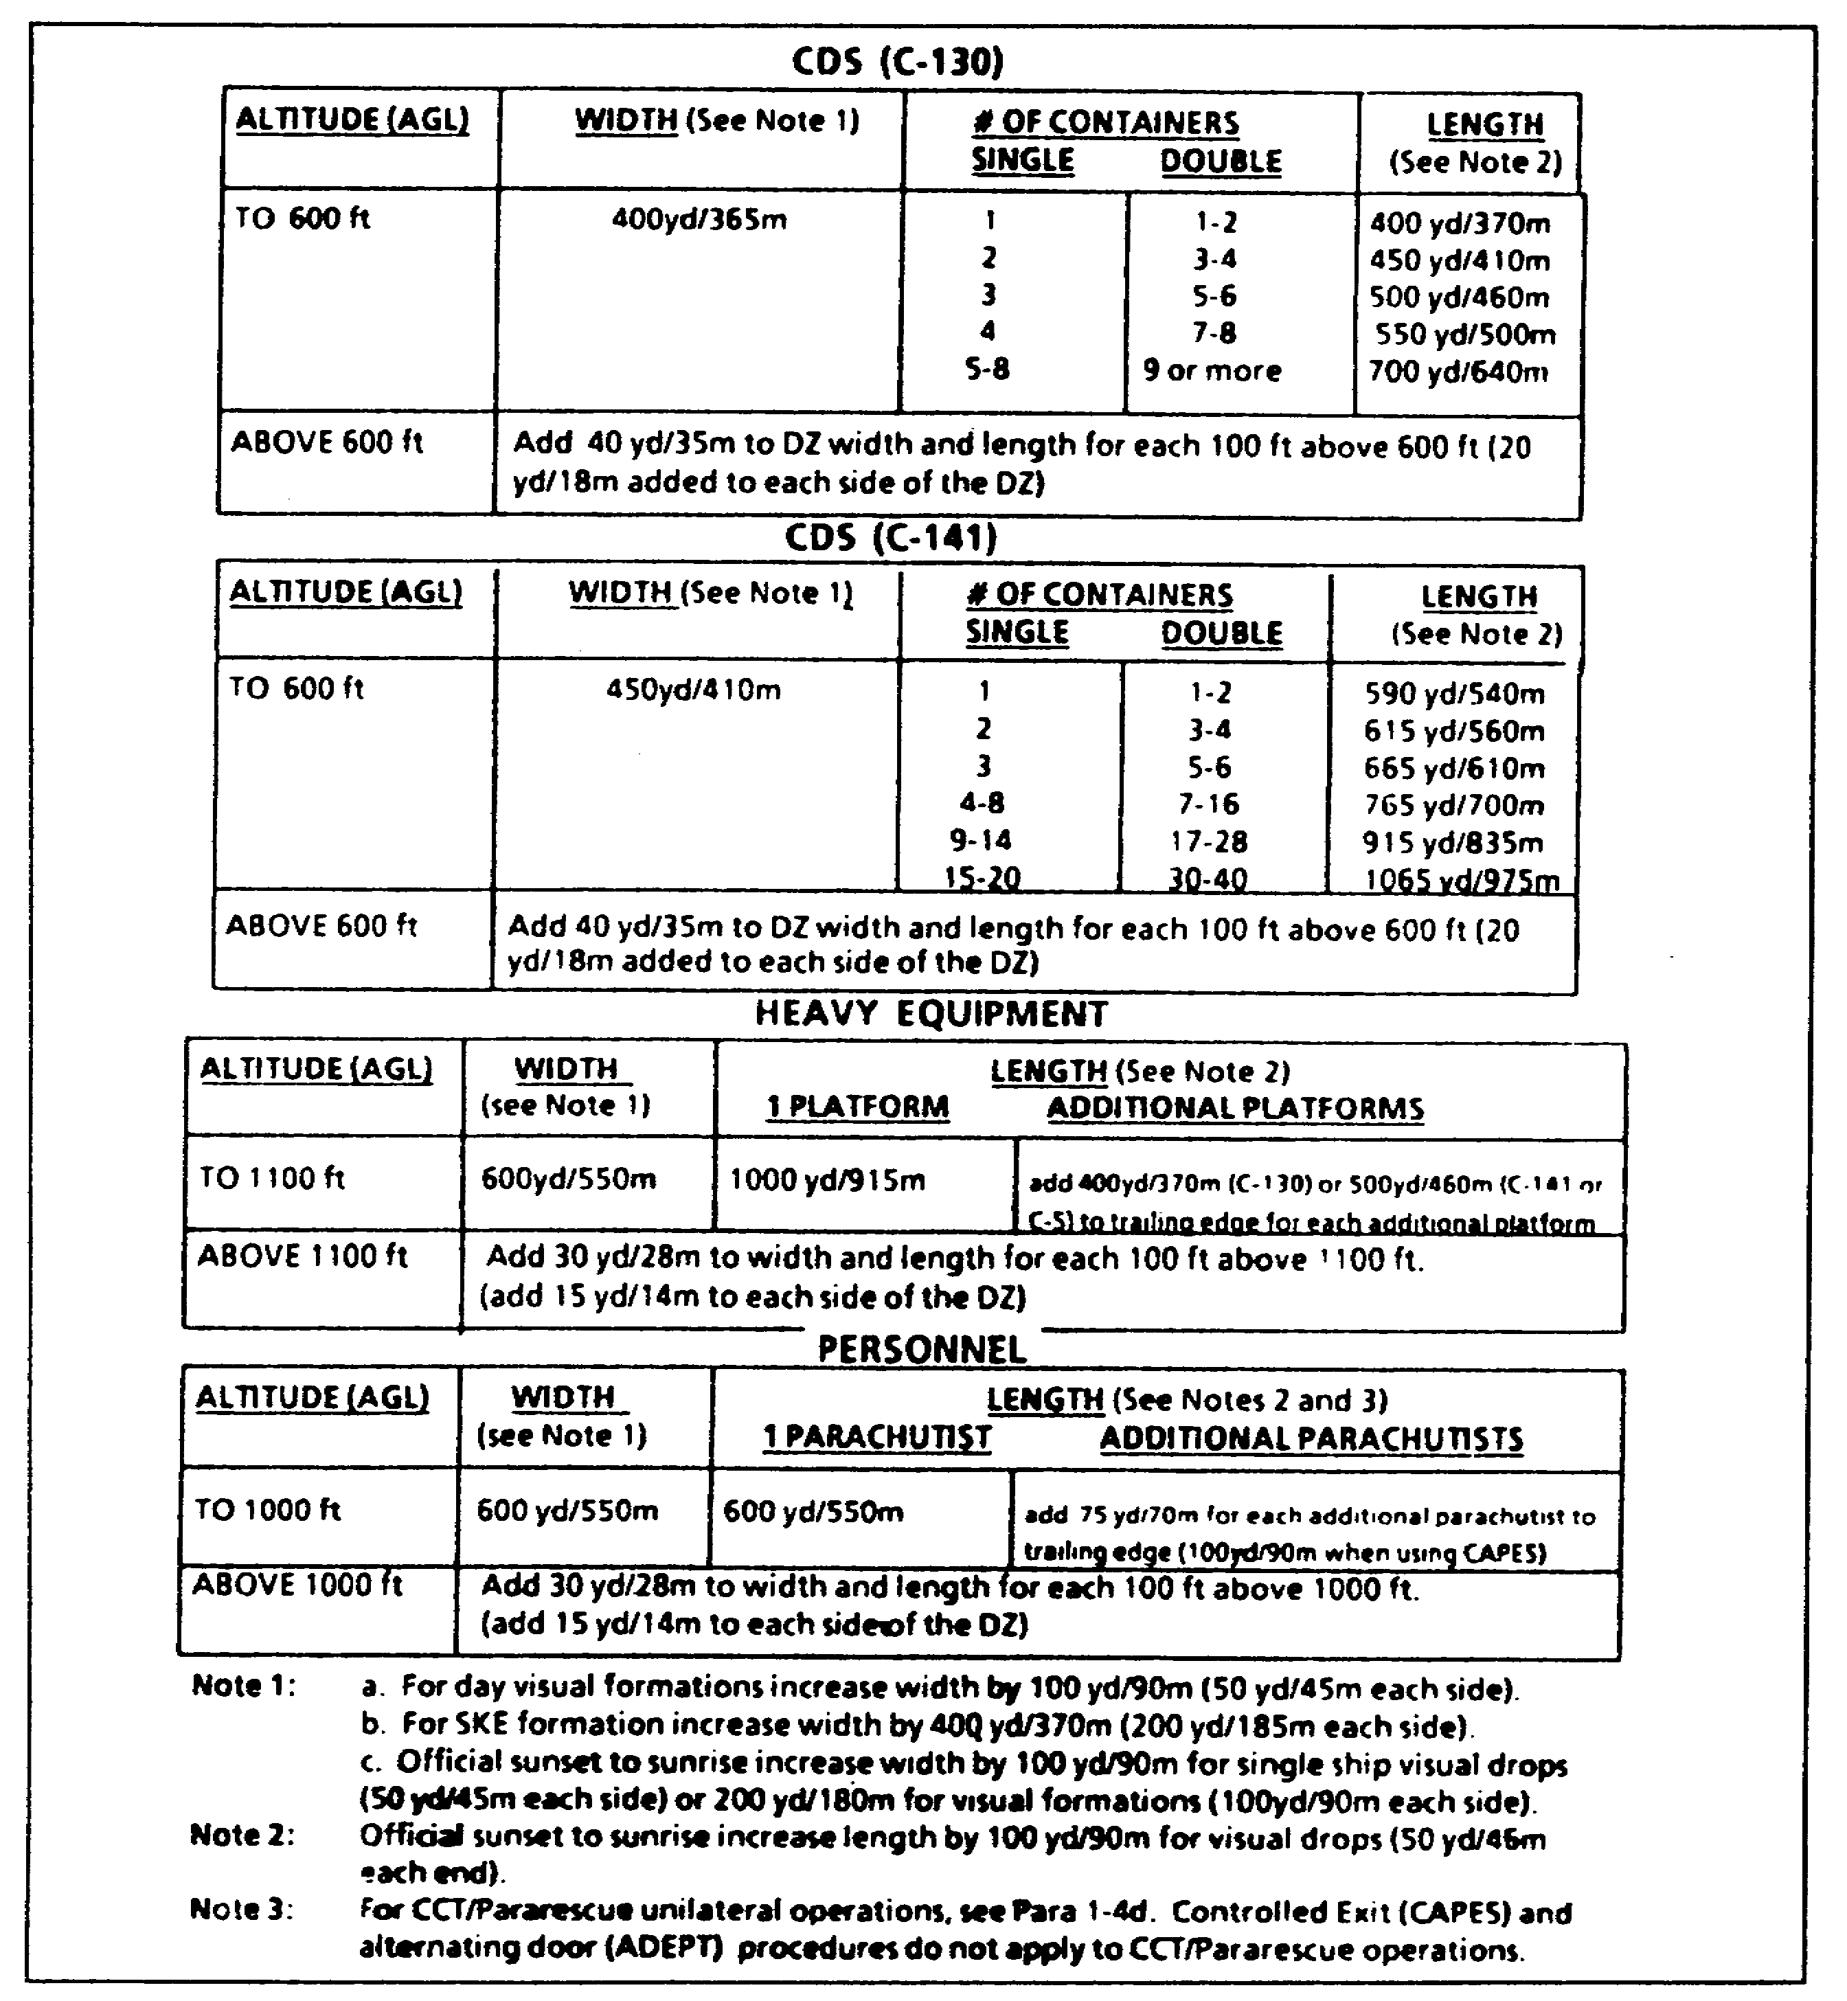

Figure 1-13. Tactical airlift drop zone size criteria

1-41 QM 3507

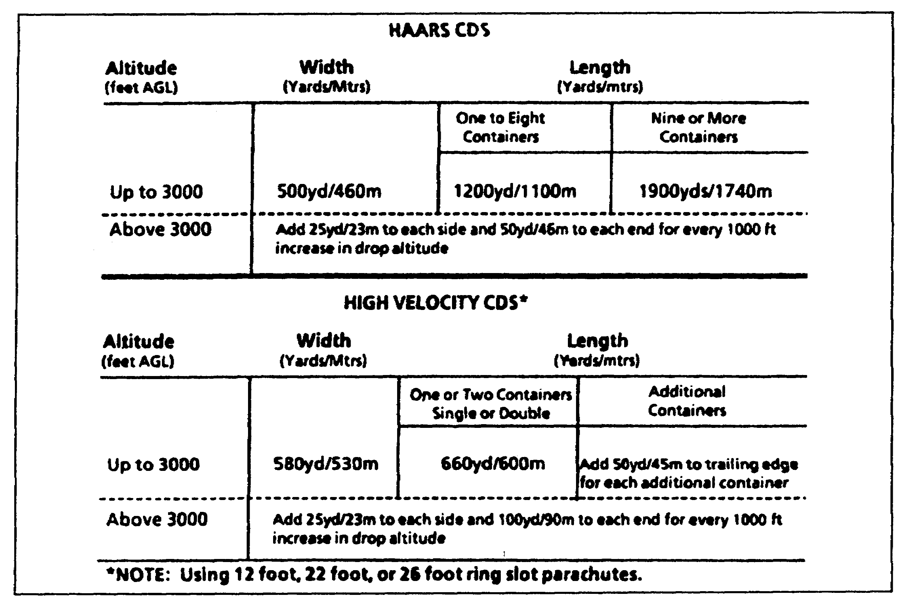

Figure 1-14. High-velocity CDS DZ size criteria

(1) Tactical Drop Zones. During exercises and contingencies, tactical DZs (DZs which have not been previously surveyed) occasionally are selected to support highly mobile ground forces. When using tactical DZs, the airlift unit assumes the responsibility for aircraft safety and the flight. The receiving unit has the responsibility for the load conditions. Determine the size of the DZ by the following items:

- Mode of delivery.
- Load dispersal statistics.
- Discussion with receiving unit.
- Professional judgment.

When selecting a DZ, also consider the recoverability of the air items and the survivability of the load. Small trees that cover the entire DZ might limit the recovery of the air items but allow a complete recovery of the load.

QM 3507 1-42

(2) Area Drop Zones. The area DZ consists of a starting point (point A) and an end point (point B), as shown in Figure 1-15. The prearranged flight path (line-of-flight) goes over a series of acceptable drop sites between these points. Make sure that the distance between point A and point B does not exceed 15 nm or 28 kilometers (km). Ensure that changes in ground elevation do not exceed 300 feet or 90 meters along the flight path. The reception committee may receive a drop at any location that is along the line-of-flight between point A and point B. Once the briefed DZ visual signal or electronic navigational aid (NAVAID) is identified and located, complete the drop. Display DZ signals and NAVAIDs or turn them on during any or all portions of a 10-minute window. Ensure that they are displayed and turned on two minutes before the scheduled arrival time of the aircraft over that segment of the DZ.

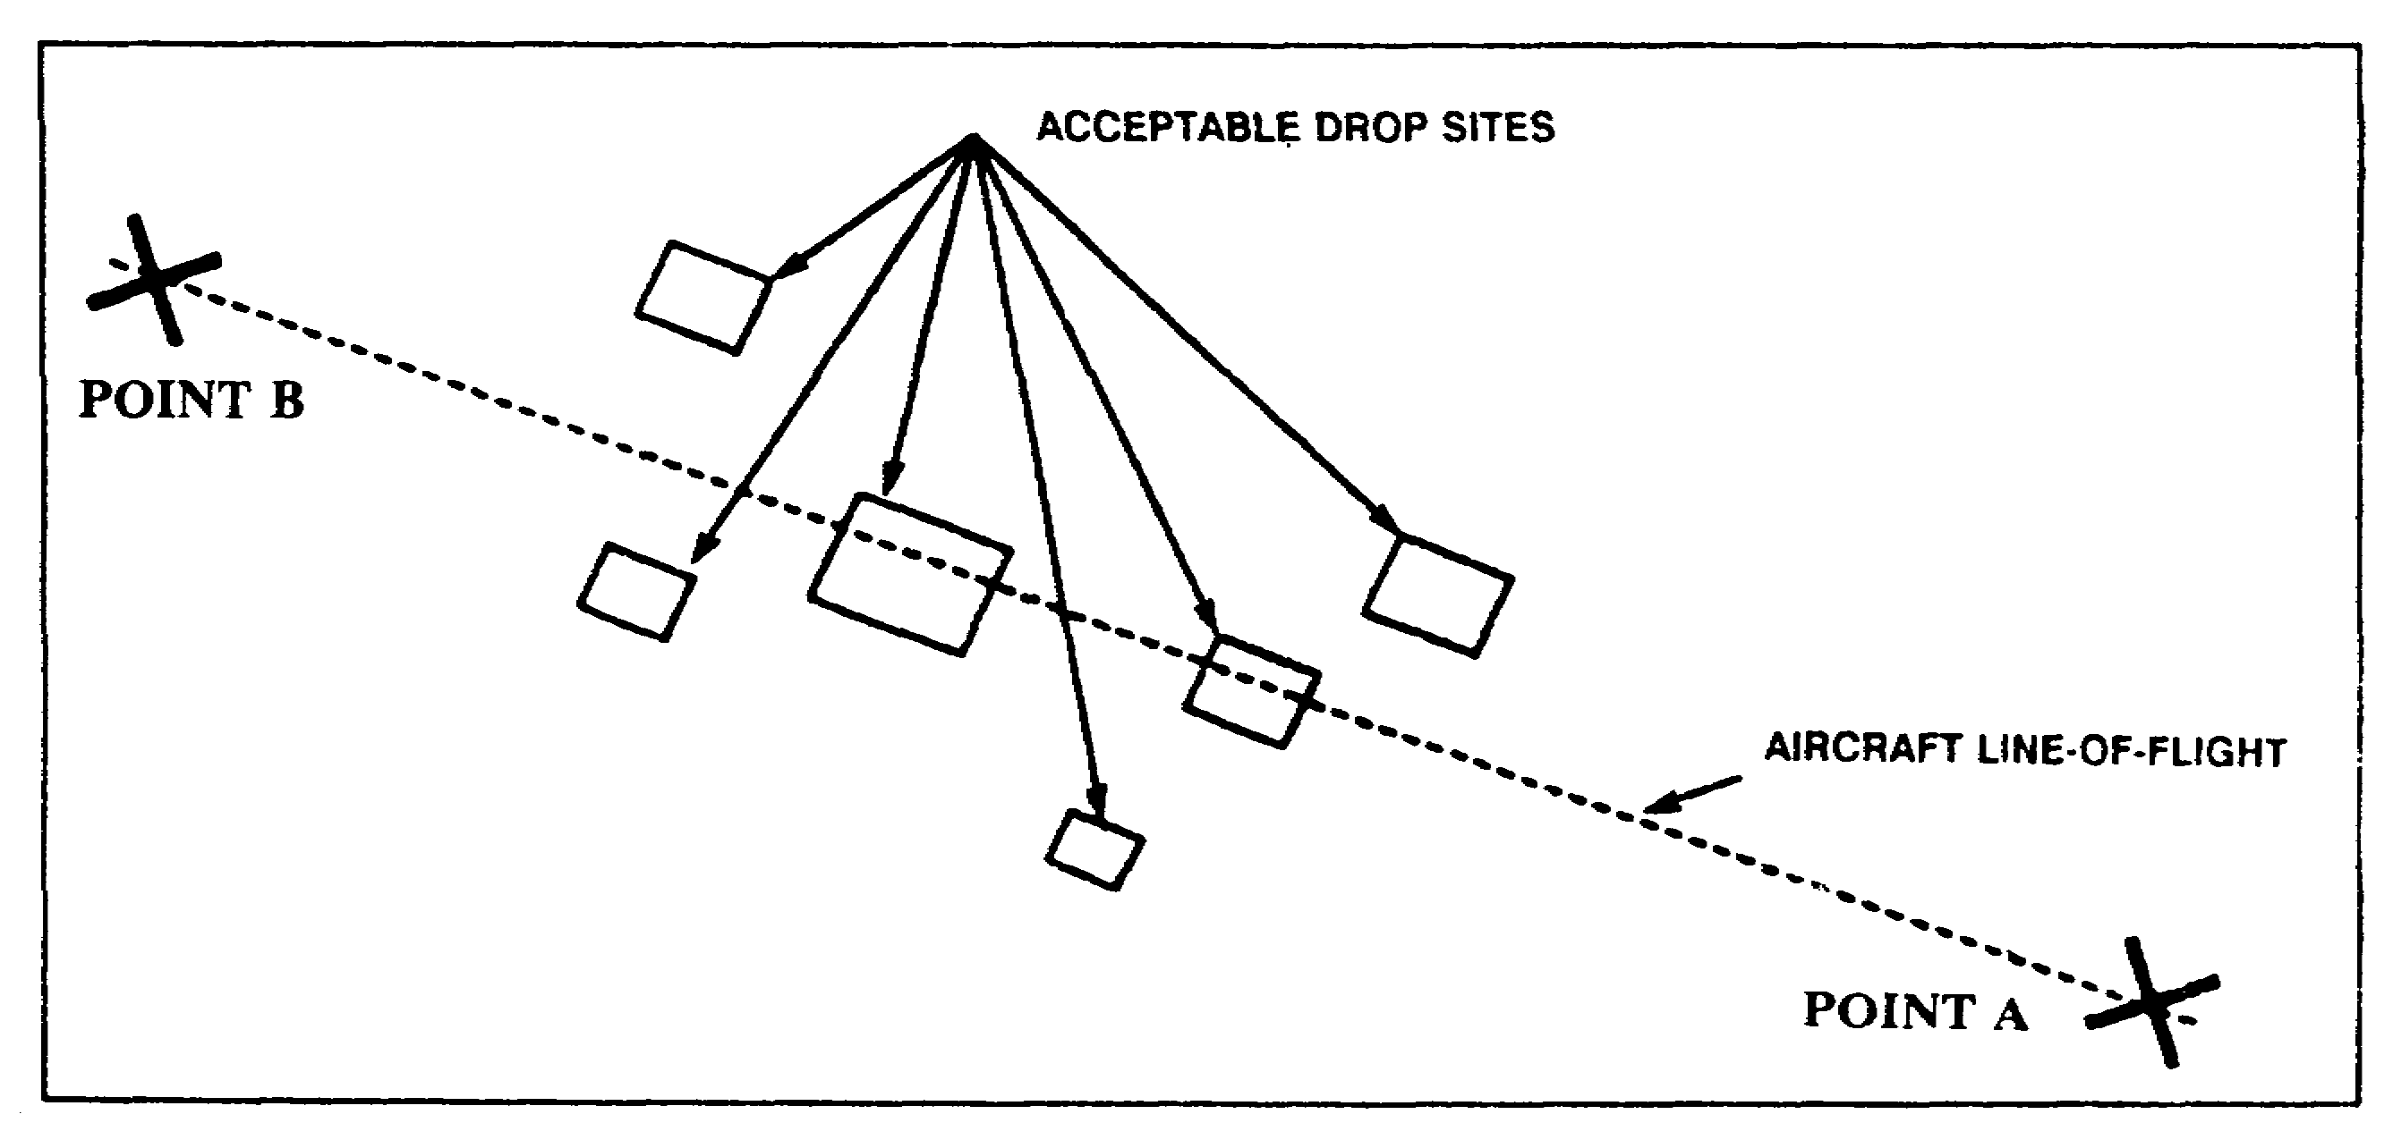

Figure 1-15. Area drop zone

(3) Circular Drop Zones. A circular drop DZ has multiple run-in headings. Determine the size of the DZ by the mission requirements and the usable terrain. The radius of a circular DZ corresponds to the minimum required distance from the point of impact to one of the trailing-edge corners of a rectangular DZ that is used for the same type and number of airdrop loads. See Figure 1-16. The entire rectangular DZ that is used for a similar purpose must fit inside the circle. Use the verbal-initiated release system (VIRS) with no markings.

1-43 QM 3507

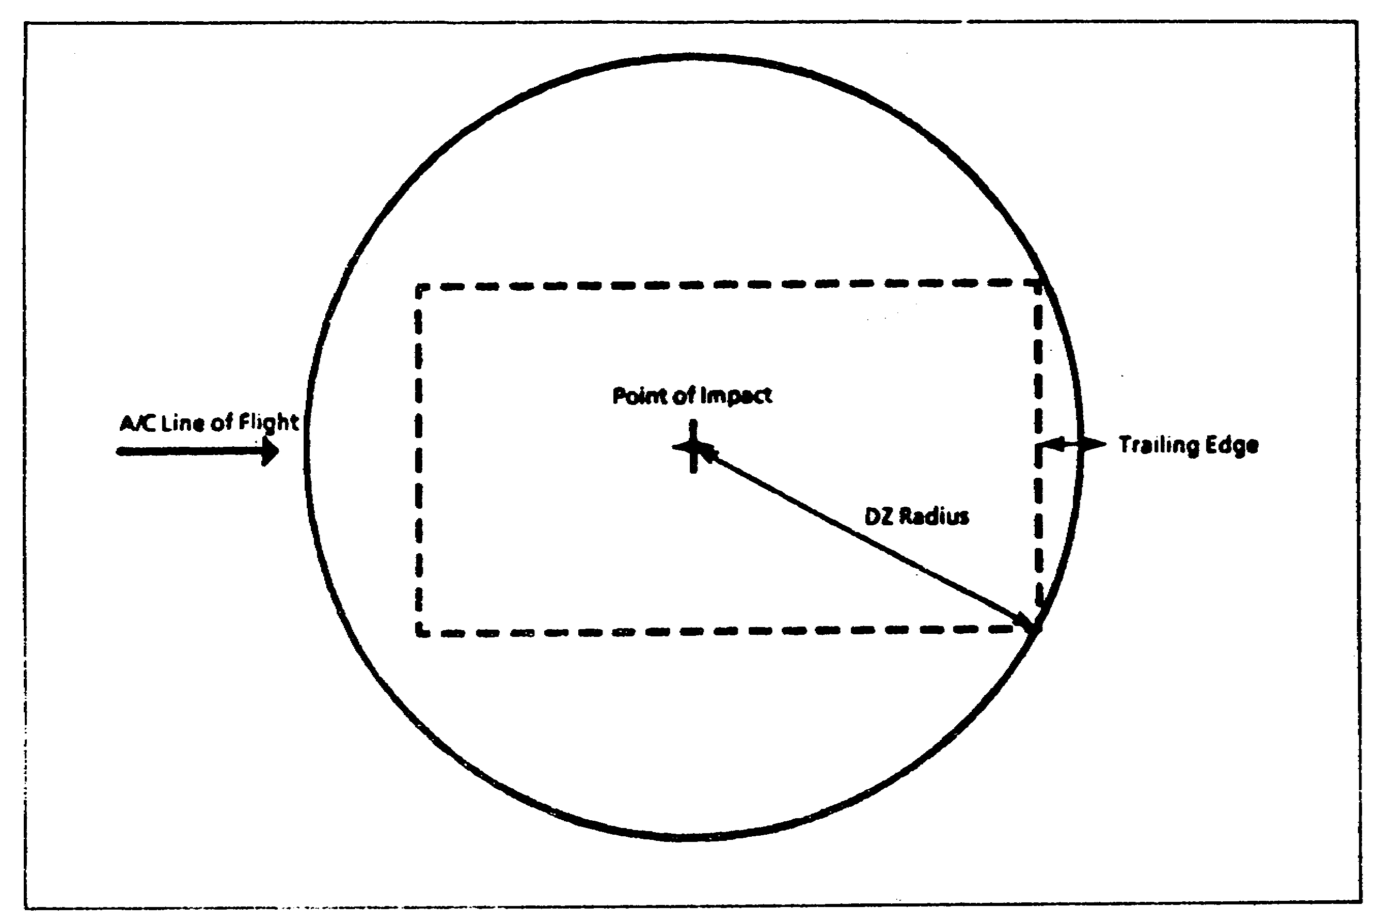

Figure 1-16. Circular drop zone dimensions

(4) Water Drop Zones. Water DZs normally are circular in shape. The point of impact (PI) of a circular DZ is normally in the center of the DZ.

b. Wind Criteria. There are no airdrop wind restrictions for altitudes other than winds at the surface. DO NOT make airdrops when surface winds (including gusts) exceed the limits that are shown in Figure 1-17 within one minute before the airdrop. However, the ground commander or user may waive the surface wind limits, as required, on a "by exception" basis.

c. Security. Intelligence reports and information concerning the types of threats that may be encountered are necessary for DZ security. The following subparagraphs describe these factors:

(1) Intelligence Coordination. Intelligence preparation of the battlefield (IPB) for combat service support (CSS) purposes considers those facets of intelligence that may have special significance for support operations. The IPB requires

QM 3507 1-44

information concerning the enemy, weather, and terrain. The CSS officers and soldiers must be aware of the value of timely intelligence and use it to their advantage.

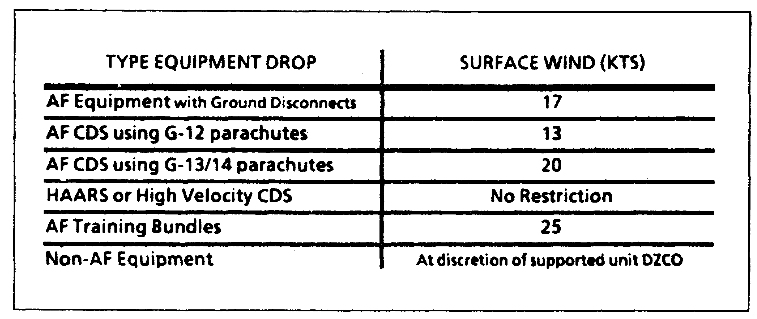

Figure 1-17. Surface wind limits for equipment airdrops

(2) Types of Threats. The threat against all rear areas is divided into three levels, which are further divided into categories. These levels do not occur independently. The fact that incidents, as defined by a certain category, are happening in one location does not mean that the next incident will be contained in the follow-on category. Therefore, DO NOT consider them a progression in the intensity of hostilities. The following subparagraphs describe the three levels of threat:

(a) Level I. The following are Level I threat categories:

- Threat-controlled agent activities.

- Sabotage by threat sympathizers.

- Activities that terrorist organizations conduct.

(b) Level II. The following are Level II threat categories:

- Diversionary operations.

- Sabotage and reconnaissance missions that tactical units conduct.

1-45 QM 3507

(c) Level III. The following are Level III threat categories:

- Ground-force penetrations.
- Airmobile operations.
- Airborne insertions.
- Amphibious operations.

d. Recovery and Evacuation Plans. Airdrop equipment is expensive and in short supply. The unit receiving the airdropped supplies derigs the loads as they land. This is done as quickly as possible so as to move the supplies and the equipment from the DZ and put them into use. Make every effort to recover and to evacuate the airdrop equipment that is used to deliver the load.

The commander of the receiving unit appoints a recovery officer to plan and to supervise the operation and to organize teams to recover and to evacuate parachute and airdrop items. You may send riggers to help the receiving unit, but the unit is responsible for the recovery. When there are no riggers on the site, train unit personnel to recover the items.

(1) Recovery. Base the priority for the recovery and the evacuation of the airdrop equipment on how critical it is to future requirements. The recovery officer must know how much, and what type of, airdrop equipment to recover so that he can plan the mission. The plan includes the following:

- Brief all recovery personnel concerning the tactical situation. There must be an alternate recovery plan to use in case the situation changes.

- The terrain and the weather conditions at the time of the mission may make it necessary for the recovery officer to adjust the recovery plan. The number of the soldiers and the vehicles that are required for the recovery depends on the tonnage and the delivery method that are used.

- The recovery officer, the teams, and the combat unit must stay in touch with each other in case there is a change in the tactical situation.

- The time that is needed for the recovery depends on the number of the items to recover and how widely scattered is the airdrop equipment.

QM 3507 1-46

The success of the recovery and evacuation mission depends on local conditions, available personnel, and transportation. All phases of the recovery and evacuation operation require coordination between the following personnel:

- Recovery officer.
- Combat unit personnel.
- Recovery teams.
- Transportation personnel.
- Riggers (when requested).

The combat unit makes the recovery areas secure before the operation begins. Evacuate the air equipment items, when possible. Otherwise, bury or destroy the air equipment items, depending on the tactical situation. Leave the site clean.

(2) Evacuation. The recovery officer ensures that all the airdrop items are evacuated quickly from the DZ. If riggers are to help retrieve the equipment, then report their assignment to the recovery officer. The riggers assist in the recovery and the evacuation of the airdrop equipment and in the preparation of reports. The riggers also may go with the evacuated equipment. Use available transportation for evacuation. When ground vehicles are used, ensure that guards go with each vehicle to safeguard the load against damage or pilferage en route.

The evacuation of the parachutes and the rigging must be quick and direct because they will be needed for airdrops in the future. Make sure that personnel are careful not to damage the parachutes when they evacuate them.

e. Special Drop Zone Preparations for Low-Altitude Parachute-Extraction System Requirements. Proper site selection for the EZ depends on a variety of conditions. Specific criteria are used in physically locating the EZ to ensure a safe operation. Figure 1-18 lists these criteria.

(1) Approach Zones. The approach path for LAPEs consists of the initial and the final approach zones. These two zones overlap and use different glide slope ratios for obstacle clearance.

(a) Initial Approach. The initial approach zone is 10,500 feet long. It starts at 11,000 feet. It ends at 500 feet (at the release panels) from the leading edge of the impact and slide-out zone. The recommended glide slope ratio for obstacle clearance within this zone is 35:1.

1-47 QM 3507

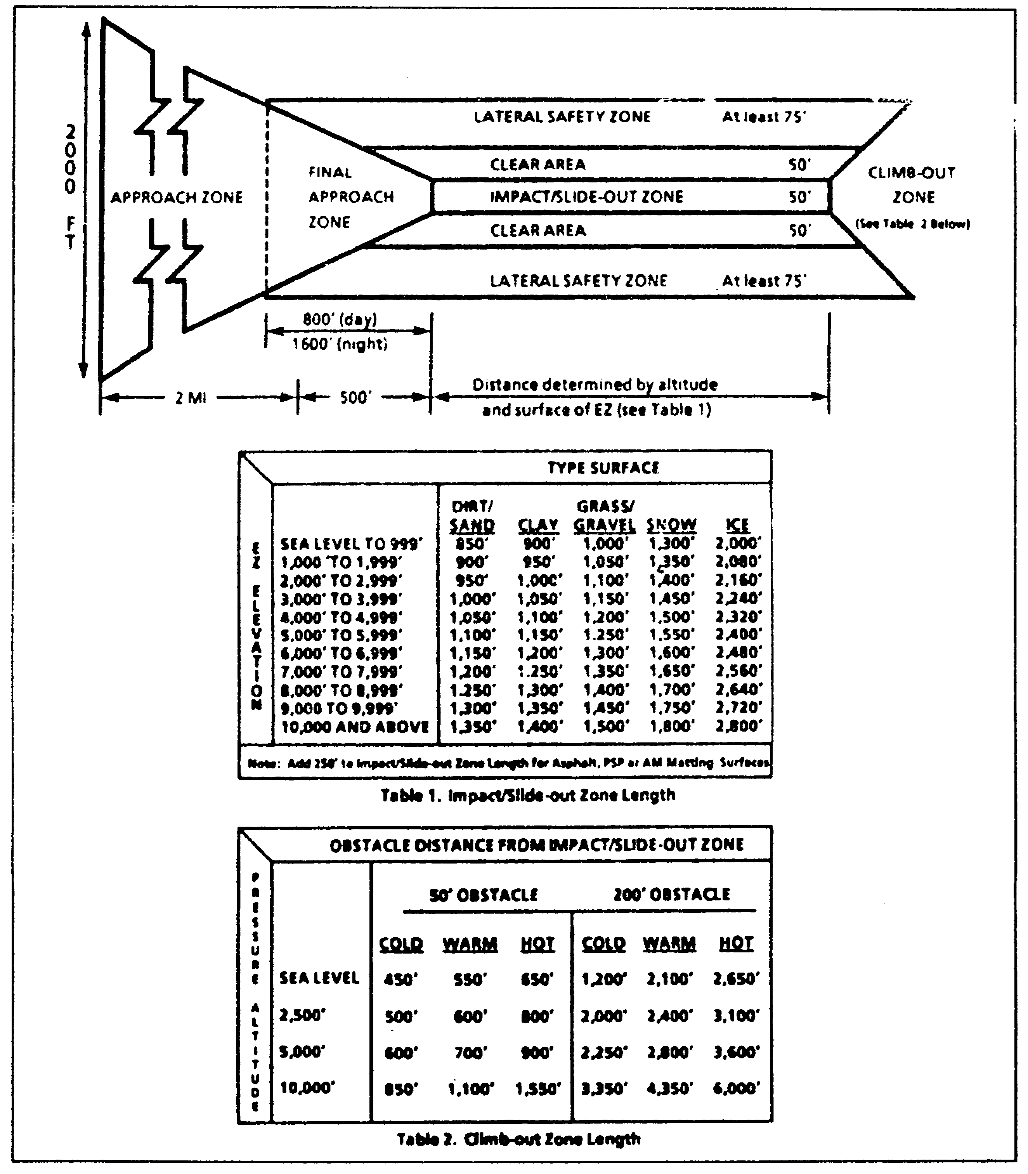

Figure 1-18. EZ Criteria

QM 3507 1-48

(b) Day Operations for Final Approach. For day operations, the final approach zone on the leading edge of the impact and slide-out zone consists of two 400-foot zones (800 feet in total length).

- The inner 400-foot zone is a graduated slope. Limit the obstacles to the maximum heights of 1 foot at the leading edge and 12 feet at the farthest edge from the impact and slide-out zone.

- The outer 400-foot zone is a graduated slope. Limit the obstacles to the maximum heights of 12 feet at the inner edge and 50 feet at the outer edge.

- The inner zone of the final approach zone must be clear so that the impact panels are visible clearly to the aircraft (because of the steep aircraft approach). The approach zone slope must not exceed a 15:1 ratio.

(c) Night Operations for Final Approach. For night operations, the final approach zone on the leading edge of the impact and slide-out zone consists of two zones. One zone is 600 feet in length. The other is 1,000 feet in length. The total length of both zones combined is 1,600 feet.

- The 600-foot zone is nearer to the impact and slide-out zone. It is a level area. Do not allow any obstacles over 1 foot high in this area.

- The 1,000-foot zone is a graduated slope. Limit the obstacles in this area to the maximum heights of 1 foot at the inner edge and 12 feet at the outer edge.

- The entire portion of the final approach zone must be clear to make the approach zone and the impact area lights clearly visible to the aircraft.

(2) Impact and Slide-Out Zone. The impact and slide-out zone is to be clear of obstructions and relatively flat. The zone may contain the following:

- Grass.
- Dirt.
- Sand.
- Short, light brush.

1-49 QM 3507

- Snow.

(3) Clear Area. The clear area is a graduated slope. The obstacles may be no more than 1 foot high adjacent to the impact and the slide-out zone and no more than 2 feet high at the outer edge.

(4) Lateral Safety Zone. The lateral safety zone is a graduated slope. Ensure that the obstacles are no more than 2 feet high at the inner edge and no more than 12 feet high at the outer edge.

(5) Climb-Out Zone. The climb-out zone may contain no obstructions that prevent a loaded aircraft from maintaining a normal obstacle clearance climb rate after an inadvertent touchdown, delivery abort, or extraction malfunction.

2. Drop Zone Markings.

Mark DZs with a raised angle marker (RAM) or VS-17 marker panels, omnidirectional visible lighting systems, and rotating light beacons (if required). Any type of conspicuous or visual marking system is acceptable if all the units are briefed and agree on the marking system.

a. Day Markings. Day markings or visual acquisition devices include, but are not limited to, the following:

- Colored smoke.

- Mirrors.

- Railroad fuses.

- Reflective or contrasting marker panels such as space blankets.

- Geographic points, in some instances.

b. Night Markings. Night markings or acquisition aids include the following:

- B-2 light guns.
- Flares.
- Fire or fire pots.
- Railroad fuses.
- Flashlights.
- Chemlites.

Combat control units also may use specialized clandestine infrared (IR) lighting systems. Use electronic markings for

QM 3507 1-50

either day or night operations. Refer to Figure 1-19 for drop zone markings.

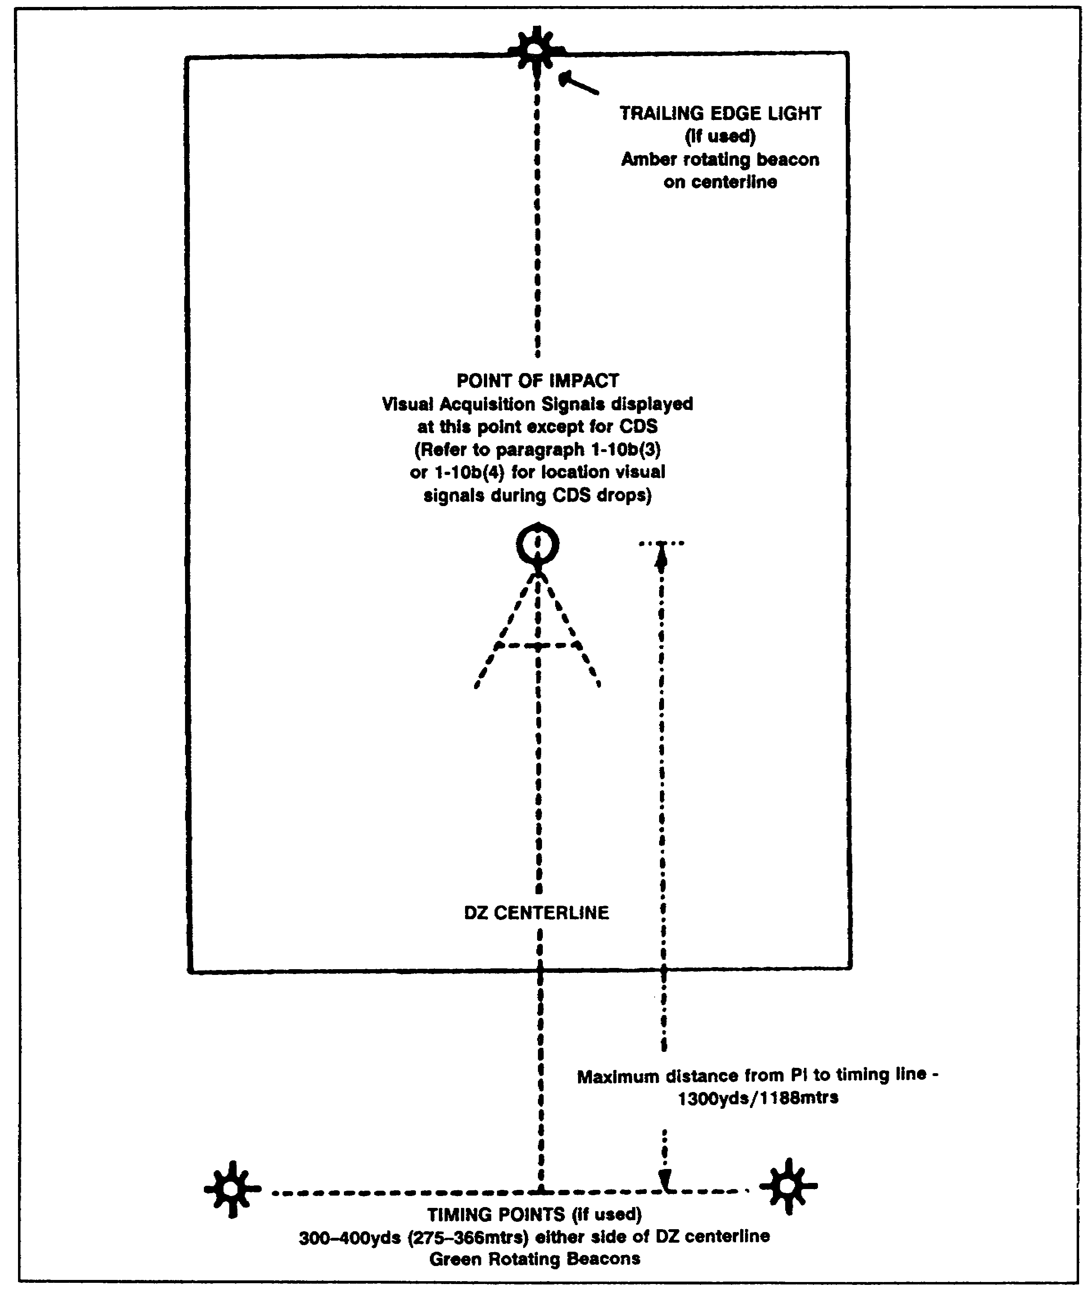

Figure 1-19. Drop zone markings

1-51 QM 3507

3. Drop Zone Personnel.

Most airdrop resupply operations are conducted without an Air Force combat control team. Therefore, the receiving unit operates the DZ. This includes communications with the Air Force crew that is flying the mission. A DZ is operational when key personnel arrive to control the DZ, to mark the DZ, and to take wind readings. The drop zone support team (DZST) is composed of Army personnel who are used in small joint airdrop operations. The DZ also has a drop zone safety officer (DZSO).

4. Drop Zone Surveys.

There are three types of DZ surveys. Refer to the following subparagraphs for details:

a. Complete Survey. The complete survey qualifies a DZ for use by any airborne force or aircraft. The complete survey is conducted in advance of the planned use. The tactics personnel perform the following actions:

- Analyze the charts.

- Determine ingress and egress routes.

- Physically inspect the DZ to ensure that it complies with Military Airlift Command (MAC) DZ criteria.

b. Tactical Survey. The tactical survey is a rapid survey and approval of the DZ. Use tactical surveys during training exercises or contingencies and to provide COMALF, COMAFSOF, or ACC with a method to respond rapidly to a user request. Restrict tactical surveys to resupply or single aircraft airdrops. Accomplish tactical surveys in an abbreviated manner. The tactical survey still requires a physical inspection of the DZ by the combat control team (CCT) tactical airlift liaison officers (TALOs). The physical inspection provides a chart analysis of the proposed route of the flight to ensure the safety of the flight of the aircraft.

If there is a need for a tactical survey concerning an existing survey to meet new run-in axis requirements, you need only a chart survey and a review of the existing survey.

c. Drop Zone Survey Approval. Units forward completed survey packages to the appropriate wings or special operations squadron tactics function for review and analysis. The tactics function performs the chart analysis and forwards the survey to the wing or the group duty officer (DO) or to the overseas special operations squadron commander for approval. Forward a copy of the survey to the appropriate MAC waiver authority for a

QM 3507 1-52

final review. The MAC waiver authority includes the survey in the AZAR. The appropriate MAC waiver authority grants all waivers. The items in the survey package includes the following:

- A fully completed MAC Form 339. (See Figure 1-20 and Figure 1-21.)

- Large-scale (1:50,000) map sheets in order to depict an area of a 5-nautical-mile radius from the center of DZ (if available).

- Aerial photos of the DZ (if available).

- User point of contact and automatic voice network (AUTOVON).

- Any other relevant data.

d. Tactical Drop Zone Survey Approval. The approval authority for tactical surveys is for the duration of the operation. Waiver authority is the responsibility of the granting MAC. Electronic transmissions of requests and surveys make a MAC Form 339 not necessary.

(1) Requests for Tactical Surveys. Forward requests for tactical surveys through the appropriate coordination channels to the exercise or the contingency approval authority. Ensure that requests include the following items:

- Proposed DZ coordinates (latitude and longitude) and six-digit universal transverse mercator (UTM) coordinates.

- Proposed approach axis (degrees, magnetic).

- DZ size.

- Proposed use (type load).

- Requesting unit (including point of contact [POC]).

1-53 QM 3507

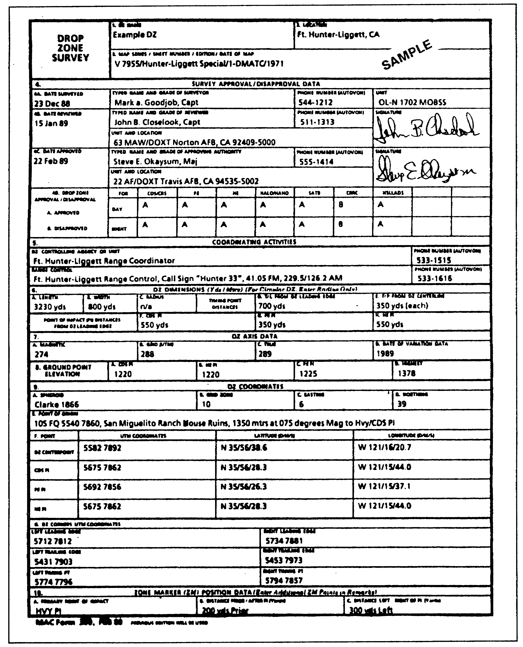

Figure 1-20. MAC Form 339, Drop Zone Survey (front)

QM 3507 1-54

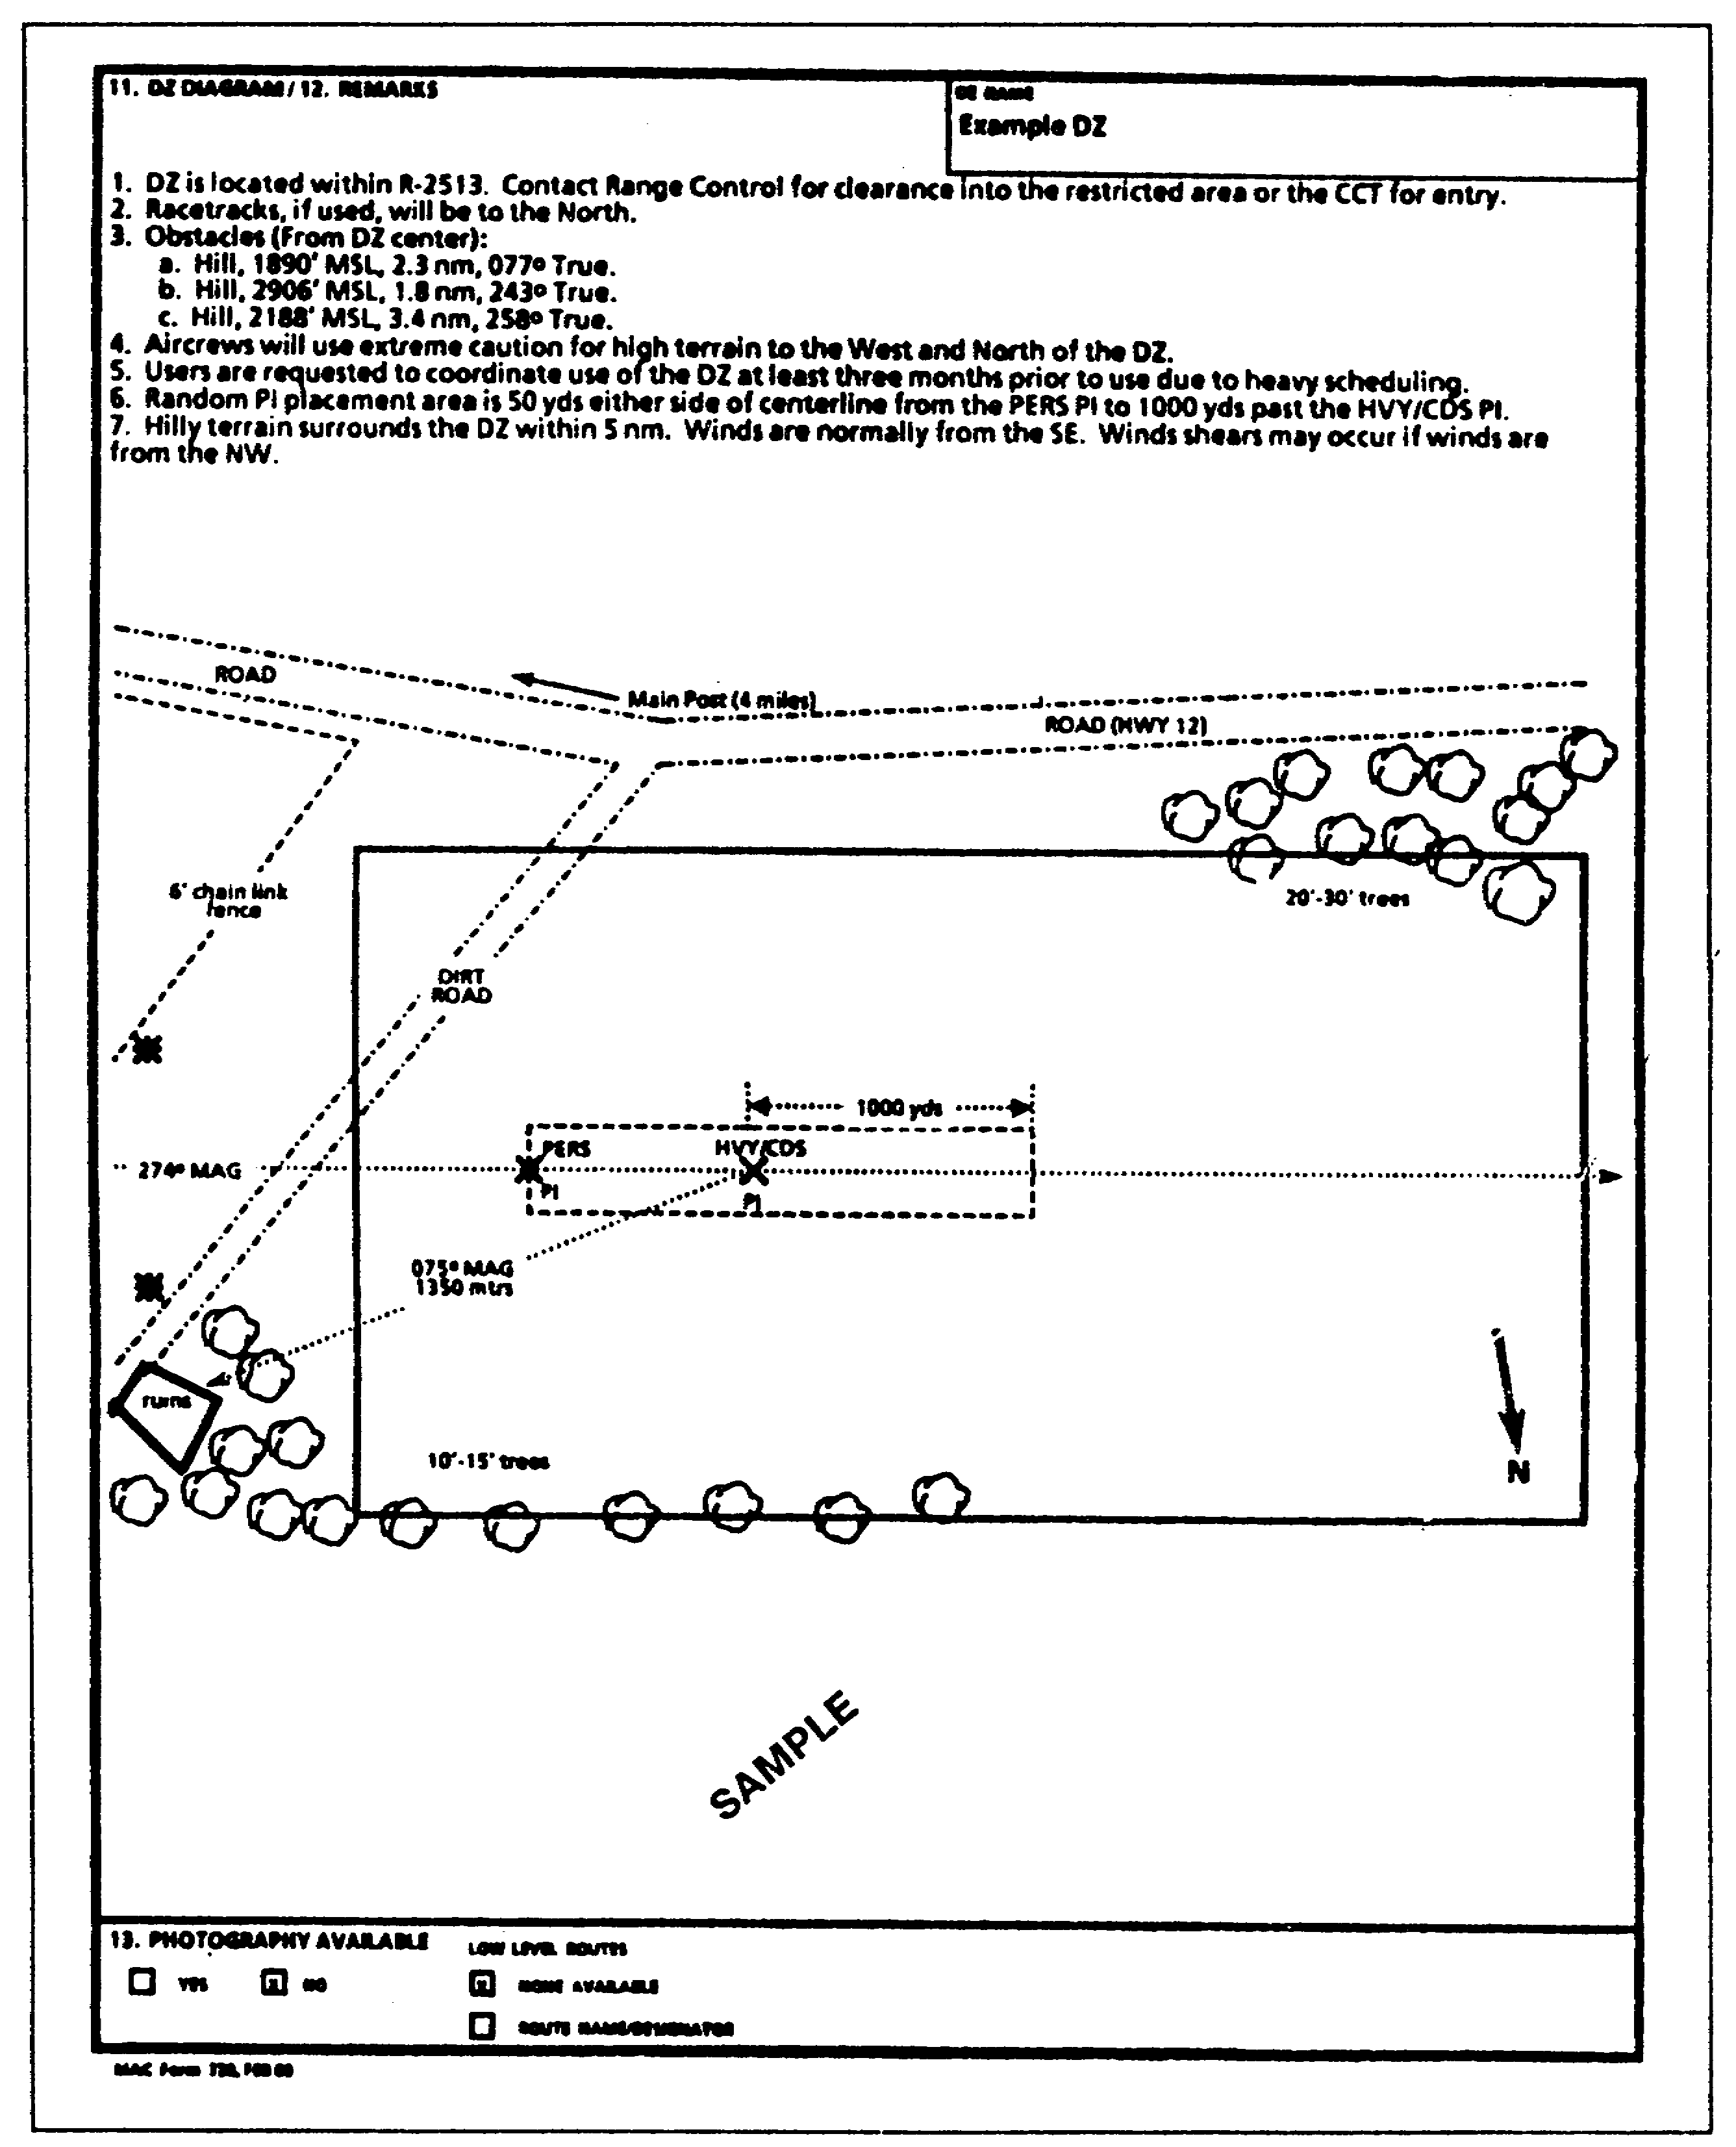

Figure 1-21. MAC Form 339, Drop Zone Survey (back)

1-55 QM 3507

(2) Performance of the Survey. After the receipt of the request by the approval authority, the approval authority assigns the appropriate agency (CCT, TALO or user) to perform the survey.

Authorized using units may submit a completed survey instead of a survey request. Forward completed surveys to the approval authority for review and approval or disapproval. The survey includes the following:

- DZ call sign or name.

- Map series or sheet number.

- Recommended approach axis (degrees, magnetic).

- Point of impact (UTM grid).

- DZ size.

- Traffic restrictions or waivers (including any unusual obstructions or terrain features that are not shown on raps).

- Requesting or using units (may use code names).

- Name and unit of the surveyor (may use a code name).

- Recommended type of drop or aerial delivery options.

- Remarks.

- Recommendations for approval or disapproval.

(3) Tactical DZ Restrictions. The following restrictions apply to the tactical DZ:

- During training exercises, locate DZs on a military reservation, on government leased property, or within a designated exercise area.

- The supported service is responsible for personal injury, parachute or load damage, and property damage.

- The CCT, the TALO, or the trained DZST personnel of the using unit operate the tactical DZ.

e. Execution Procedures. After the DZ survey is approved, the approval agency executes the following items:

QM 3507 1-56

(1) DZ Identification and Acquisition. Ensure that the aircrew, the CCT, the TALO, the DZST, and the other appropriate personnel are briefed on all the functions and details of the operation and the mission including the procedures for positive DZ identification and acquisition. Unless the requirement to do so is waived by the exercising controlling agency, use secure communications or use other authentication procedures for positive DZ identification.

(2) Drop and Aerial Delivery Options. Select one of the four drop and aerial delivery options that are described in the following subparagraphs. Base the decision to select one of the options on the following considerations:

- Tactical exercise situation.
- Terrain conditions on or near the DZ.
- Availability of maps and photographs.
- Surveyor's recommendations.

(a) Option One: Point-of-Impact Airdrop. Conduct the following in accordance with USAF publications: computed air release point (CARP), the sight angle, the adverse weather aerial delivery system (AWADS), or the station-keeping equipment-zone marker (SKE-ZM).

- The DZ party marks the PI on the DZ. The aircraft navigator computes the release point from the air.

- Day markings normally consist of eight VS-17G panels. The panels are placed flat on the ground. They form a block letter that is at least 35 feet by 35 feet. Only use the letter "A" "C," "J," "R," or "S." On circular-shaped DZs, use the letters "H" and "0." Place a RAM at the PI in place of a code letter or use it in conjunction with a code letter. When used with the code letter, place the RAM at the top of the code letter.

- Night markings consist of the same letters that are authorized for day use. Form the letters by a minimum of nine white omnidirectional lights that are placed on the surface of the DZ. On night CARP DZs, place an amber rotating beacon on the center line and on the trailing edge of the DZ.

1-57 QM 3507

- In addition to the block letter for day operations, display smoke downwind and adjacent to the point of impact. On night DZs, display a white air-traffic-control light at the control center location.

- For a CARP operation that involves a personnel drop at the PI, the point of impact is 300 yards (day) or 350 yards (night) from the leading edge.

- For a CARP CDS or a bundle drop at the PI, the point of impact is 200 yards (day) or 250 yards (night) from the leading edge.

- For a CARP heavy-equipment drop at the PI, the point of impact is 500 yards (day) or 500 yards (night) from the leading edge.

- Mark timing points for night operations if the aircrew requests that you do so. Ensure that these points are equally distant from the extended center line of the DZ, not further than 1,300 yards from the PI, and between 300 and 350 yards (350 yards minimum for C-141 aircraft) on each side of the centerline. Mark each point with a green rotating beacon. A timing point may be required for the operations. Each timing point consists of three VS-17G panels that are side by side. The location for the day timing points are the same as for the night timing points. Refer to Figure 1-22 and Figure 1-23.

- Relay no-drop conditions to the aircraft by using red smoke or red flares to form the code letter into two parallel bars that are perpendicular to flight path. Alternatively, ensure that the planned signal is absent. To indicate the cancellation of the mission, form the code letter into an "X."

- Locate the control center location for personnel drops at the PI.

- Locate the control center for a CDS drop 150 yards to the six o'clock position of the PI.

QM 3507 1-58

- Ensure that the control center for heavy equipment, free drops, high velocity, and AWADS that have a ceiling of less than 600 feet are off the DZ.

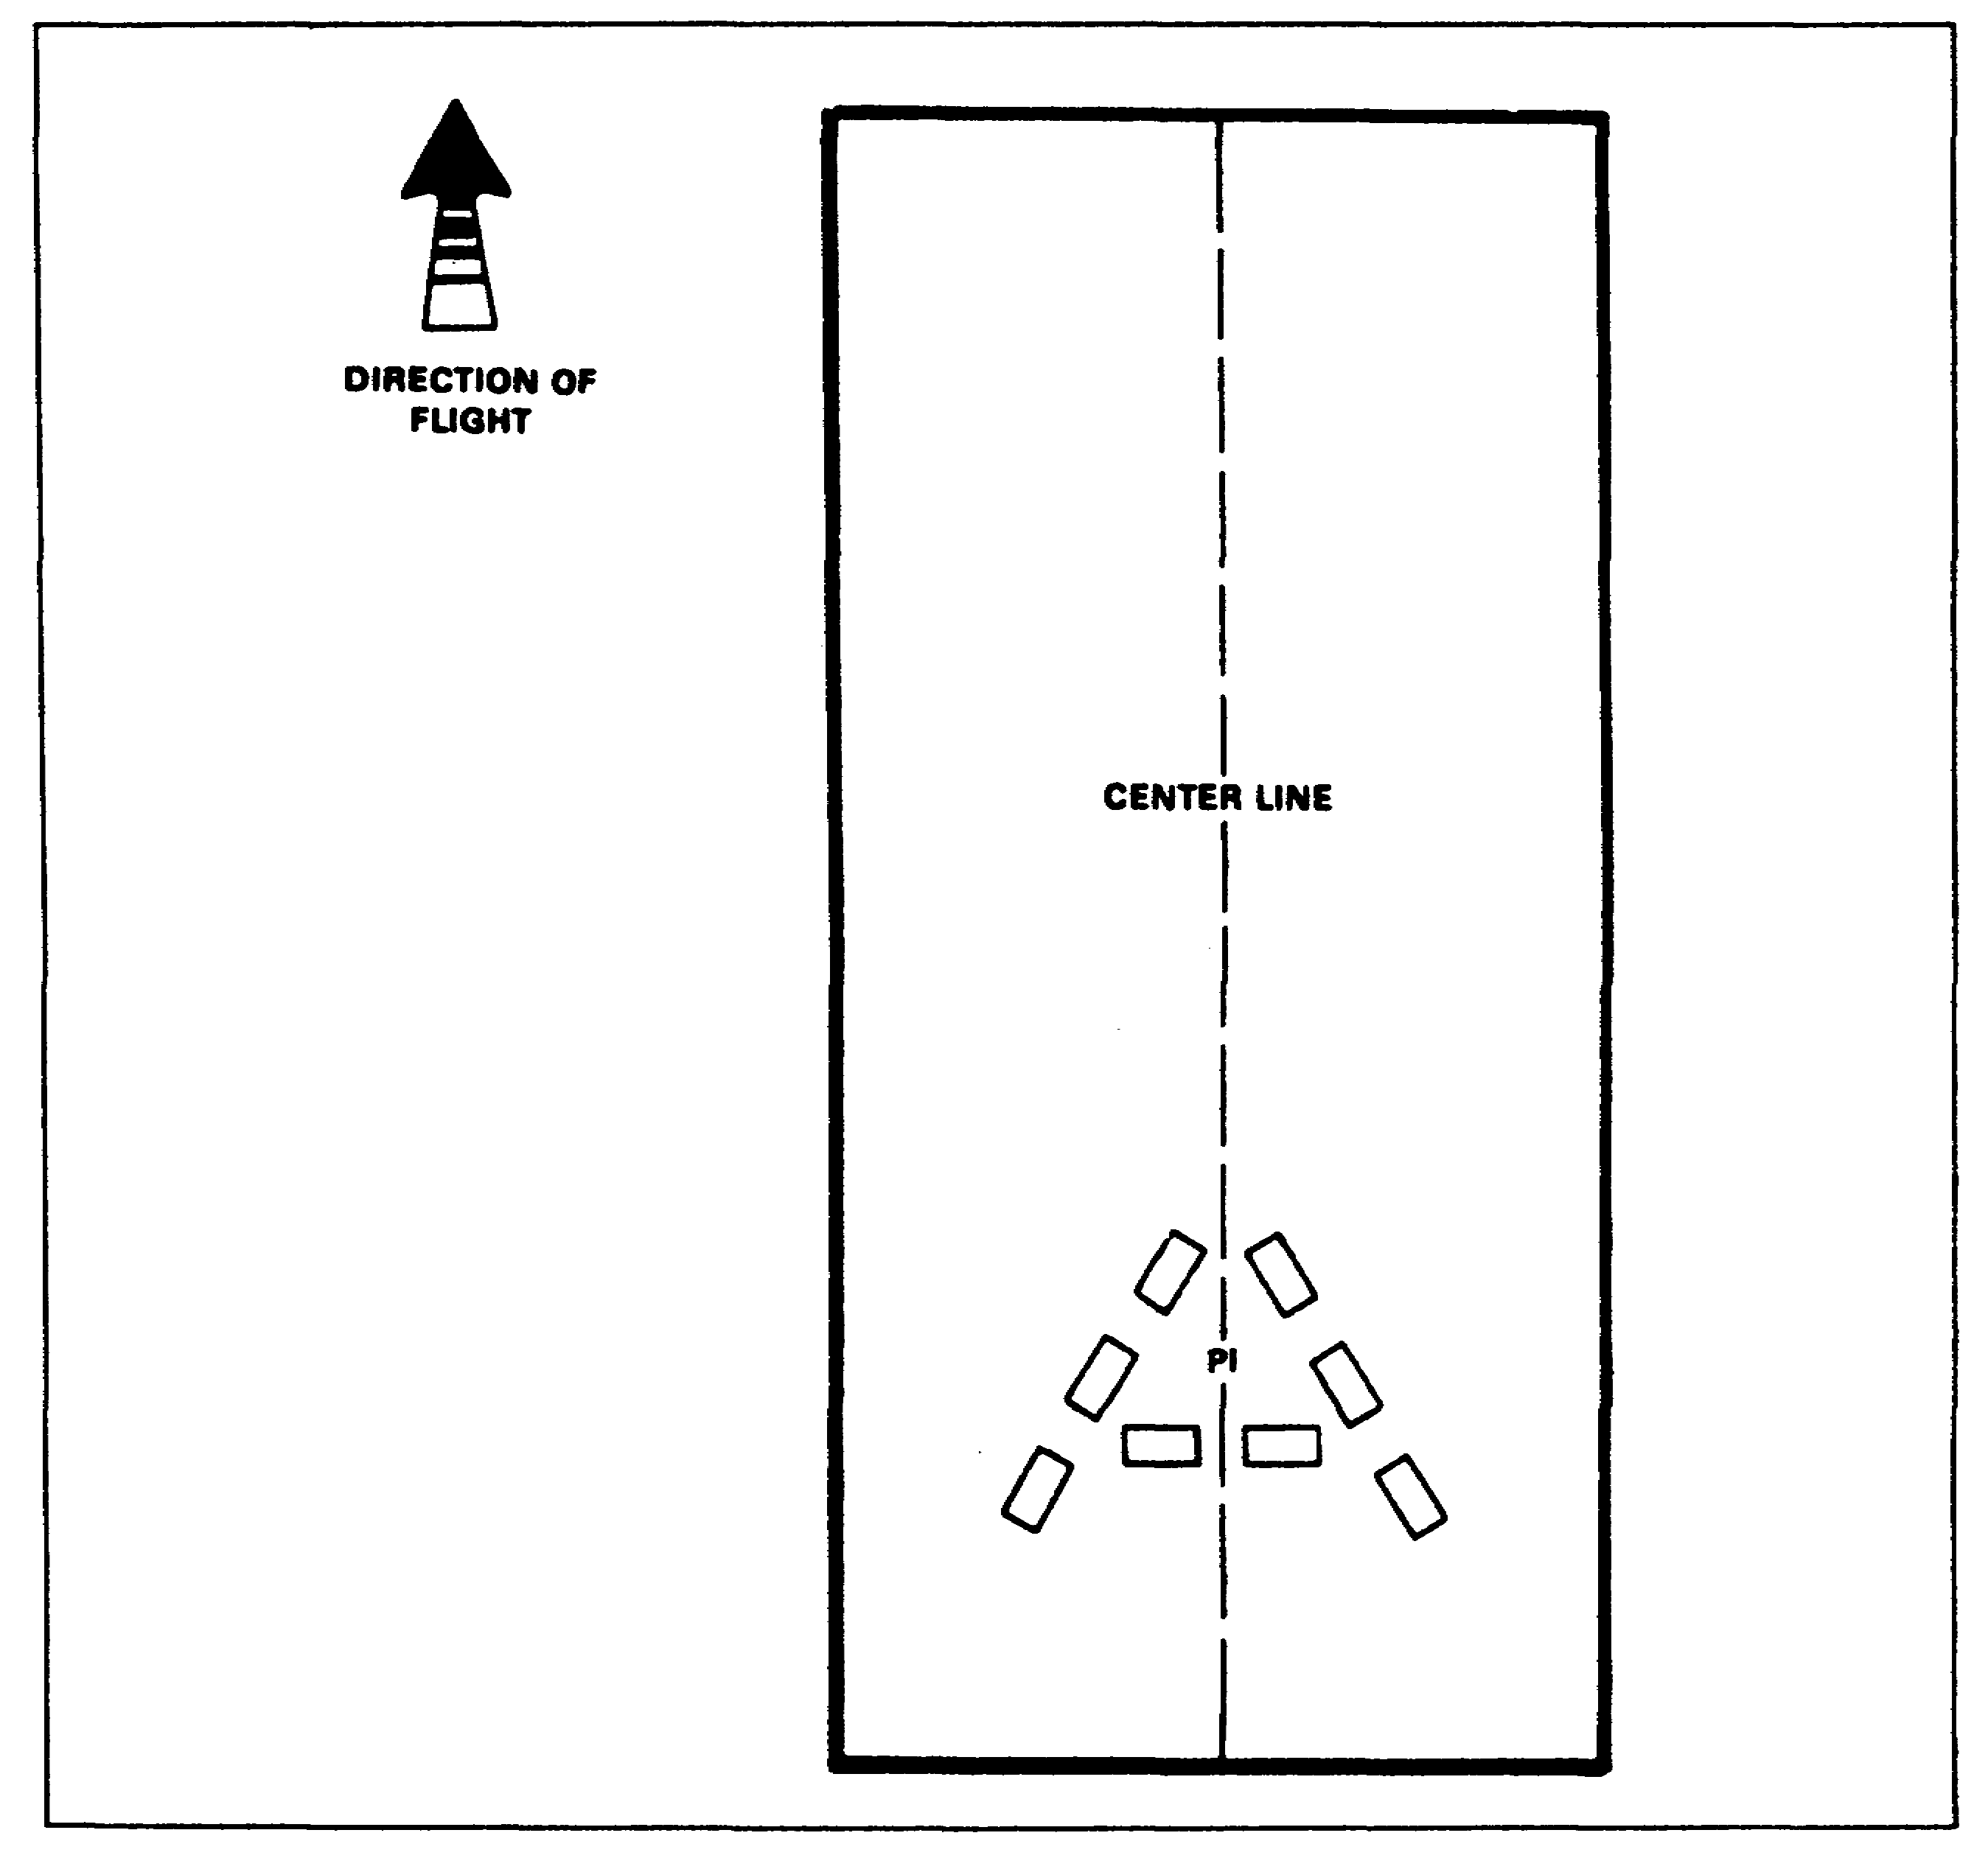

Figure 1-22. Day CARP drop zone marking

1-59 QM 3507

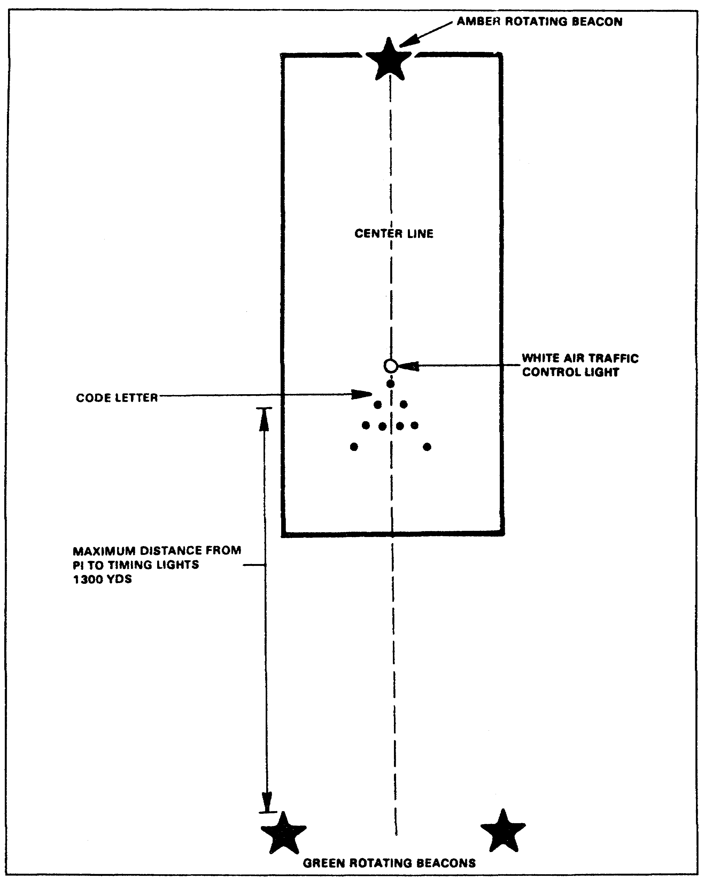

Figure 1-23. Night CARP drop zone markings

QM 3507 1-60

(b) Option Two: Ground Marked Release System. Special operations forces, CCT, or TALO personnel work the ground marked release system (GMRS) operation. The GMRS is a method of marking the release point on the DZ. The pilot uses the markings to adjust his flight path 100 meters to the right of the corner panel and parallel to the approach-corner panel axis. The GMRS uses a marking that is known as the inverted "L." When the drop aircraft is 100 meters directly to the right of the corner (A) panel, execute the drop. Refer to Figure 1-24. The following bullets describe the placement of the markings:

- From the release point (RP), move 100 meters to the left (90 degrees) of the drop heading. This is the location of the corner (A) panel. Place a VS-17G panel with the long axis or the panel parallel with the drop heading. Elevate the panel at a 45-degree angle toward the approaching aircraft to aid the aircrew and the jumpmaster in their visual identification of the DZ.

- From the corner (A) panel, move in the same direction as the preceding bullet indicates. Move 50 meters. This is the location of the alignment (B) panel. Place this panel as the preceding bullet indicates.

- From the alignment (B) panel, move 150 meters in the same direction as the previous bullet indicates. This is the location of the flanker (C) panel. Place this panel as the preceding bullet indicates.

- From the corner (A) panel, move 50 meters on the back azimuth of a drop heading. This is the location of the approach (D) panel. Place this panel as the preceding bullet indicates.

- At night, replace all the panels with a white light. Shield the lights on three sides or place them in pits.

- During daylight operations, you may display smoke at the release point. During nighttime operations, you may use a white air traffic control.

- Signal a NO DROP to the aircraft by using red smoke, red flares, scrambled panels, or by the absence of a planned signal.

1-61 QM 3507

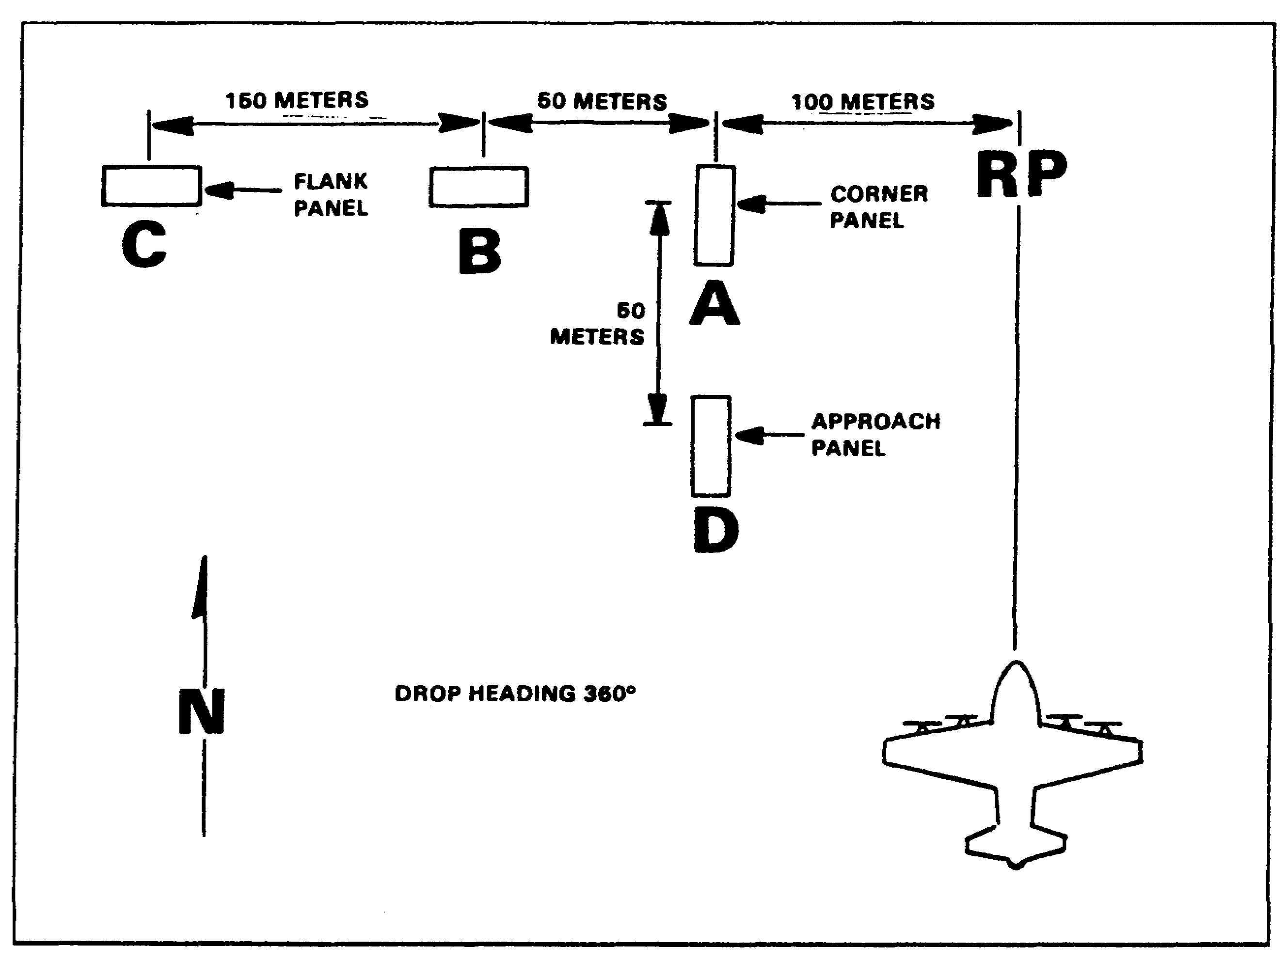

Figure 1-24. Ground marking release system

Since the aircraft must fly along the markings on the DZ, it is important that these markings be visible to the aircrew. If any portion of the inverted "L" falls within a 15 to 1 (15:1) mask clearance ratio of the obstacles on the approach end of the DZ, then place a code letter ("H," "E," "A," or "T") or the far panel on the departure end of the DZ (Figure 1-25). This far marking is on line with the corner (A) panel to allow the aircrew to begin alignment on the release point until the inverted "L" comes into view. If you employ a code letter, use it to distinguish the DZ from other DZs in the area.

(c) Option Three: Verbal-Initiated Release System. Combat control or TALO personnel conduct VIRS operations and restrict them to single aircraft operations.

QM 3507 1-62

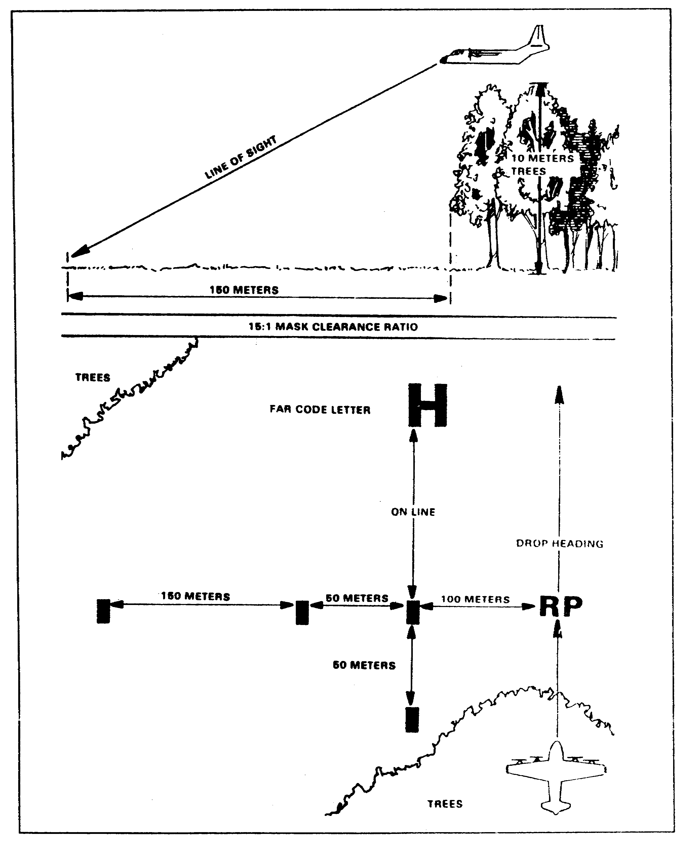

Figure 1-25. The 15:1 mask clearance ratio

1-63 QM 3507

The VIRS is a method of executing the drop over the release point by using a verbal command from the ground to the aircraft. Code letters ("H", "E," "A," or "T") mark the release point. This method of airdrop allows the conduct of the operation with a minimum amount of prior DZ information and coordination. Refer to Figure 1-26 and Figure 1-27. The aircraft flies in the given direction until the DZST or the DZSO gains visual contact with the aircraft. Once the aircraft identifies the DZ, the DZSO or DZST radio operator directs the aircraft over the release point on the drop heading. When the aircraft is directly over the RP, the command "EXECUTE" is given to initiate the drop.

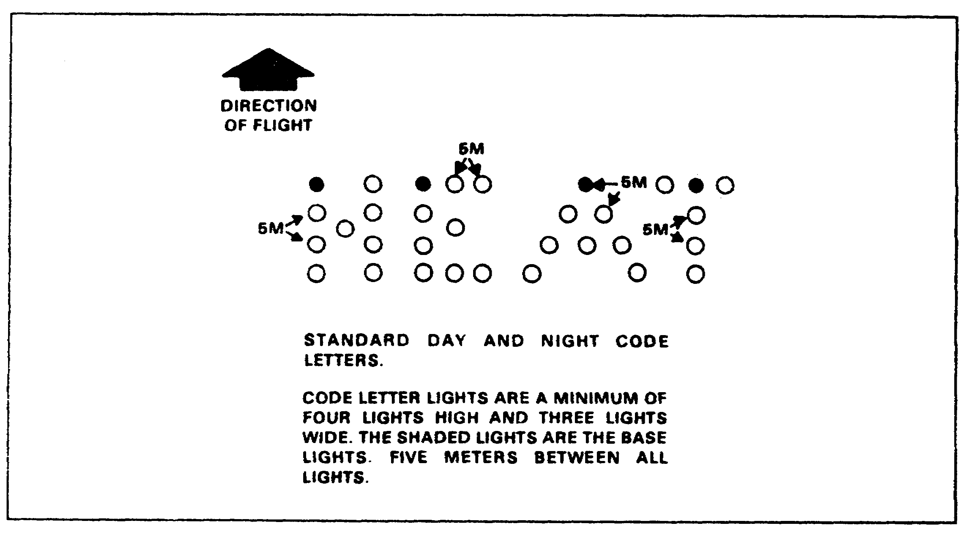

Figure 1-26. Verbal-initiated release system



Figure 1-27. Code letter day markings

QM 3507 1-64

The following are day DZ markings (Figure 1-28):

- The DZSO determines the release point. He then places the code letter on the drop heading with the base panel of the letter at the release point. He forms the code letter by placing the VS-17G panels together. Each letter is two panels high and one panel wide.

- Place the flank panel parallel to the code letter and align it with the base panel. Place the flank panel 200 meters (or at the edge of the DZ, whichever is less) to the left of the code letter.

- Place the far panel 500 meters from, or at the edge of, the DZ, whichever is closer to the base panel, and on line with the drop heading.

- Both the far and the flank panels consist of a single VS-17G panel. Elevate these panels at a 45-degree angle to improve visibility.

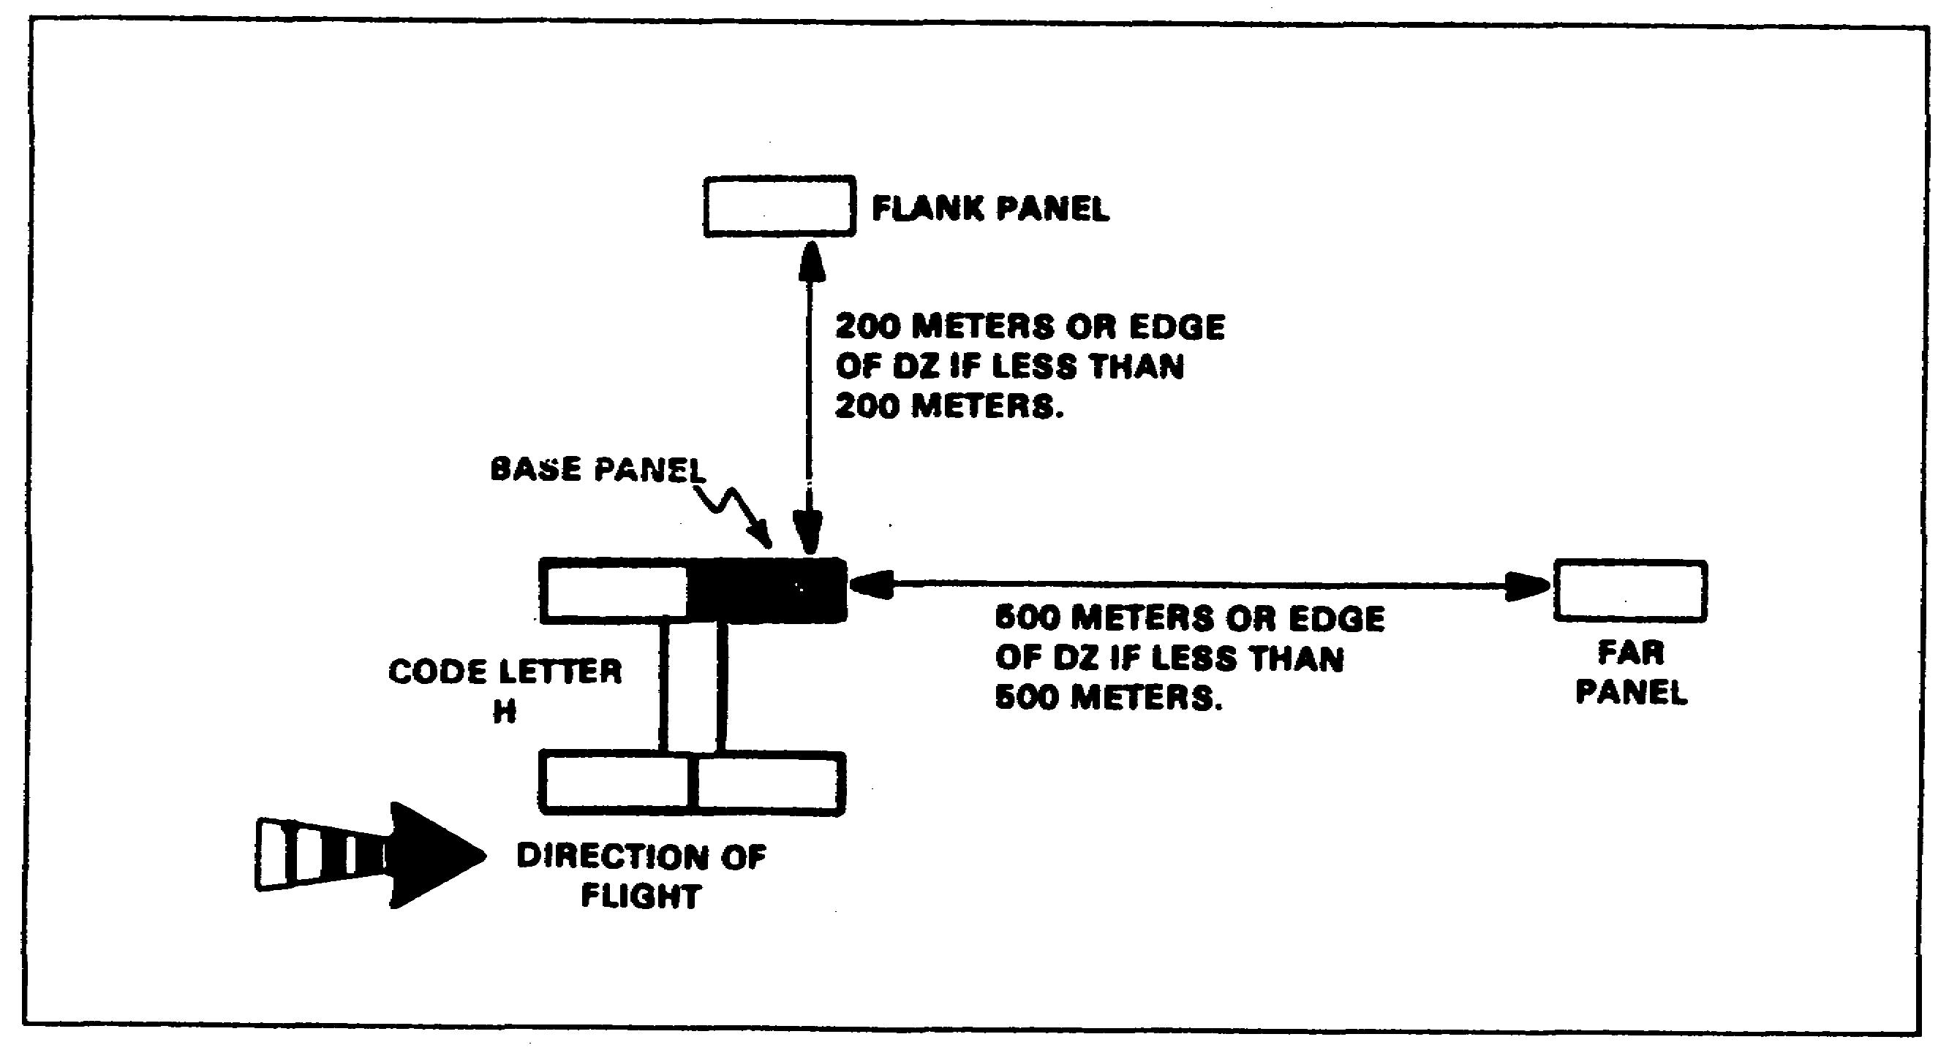

Figure 1-28. Day markings (VIRS)

1-65 QM 3507

The following are night DZ markings (Figure 1-29):

- The procedures for establishing the DZ are the same as for those that are used in night operations except that you use white light for the code letter and the far and the flank markings.

- Each code letter is four lights high and three lights wide. There is a distance of 5 meters between each light in the code letter. The far and the flank lights are signal lights. Also locate a white-and-red lens air traffic control (ATC) light at the RP.

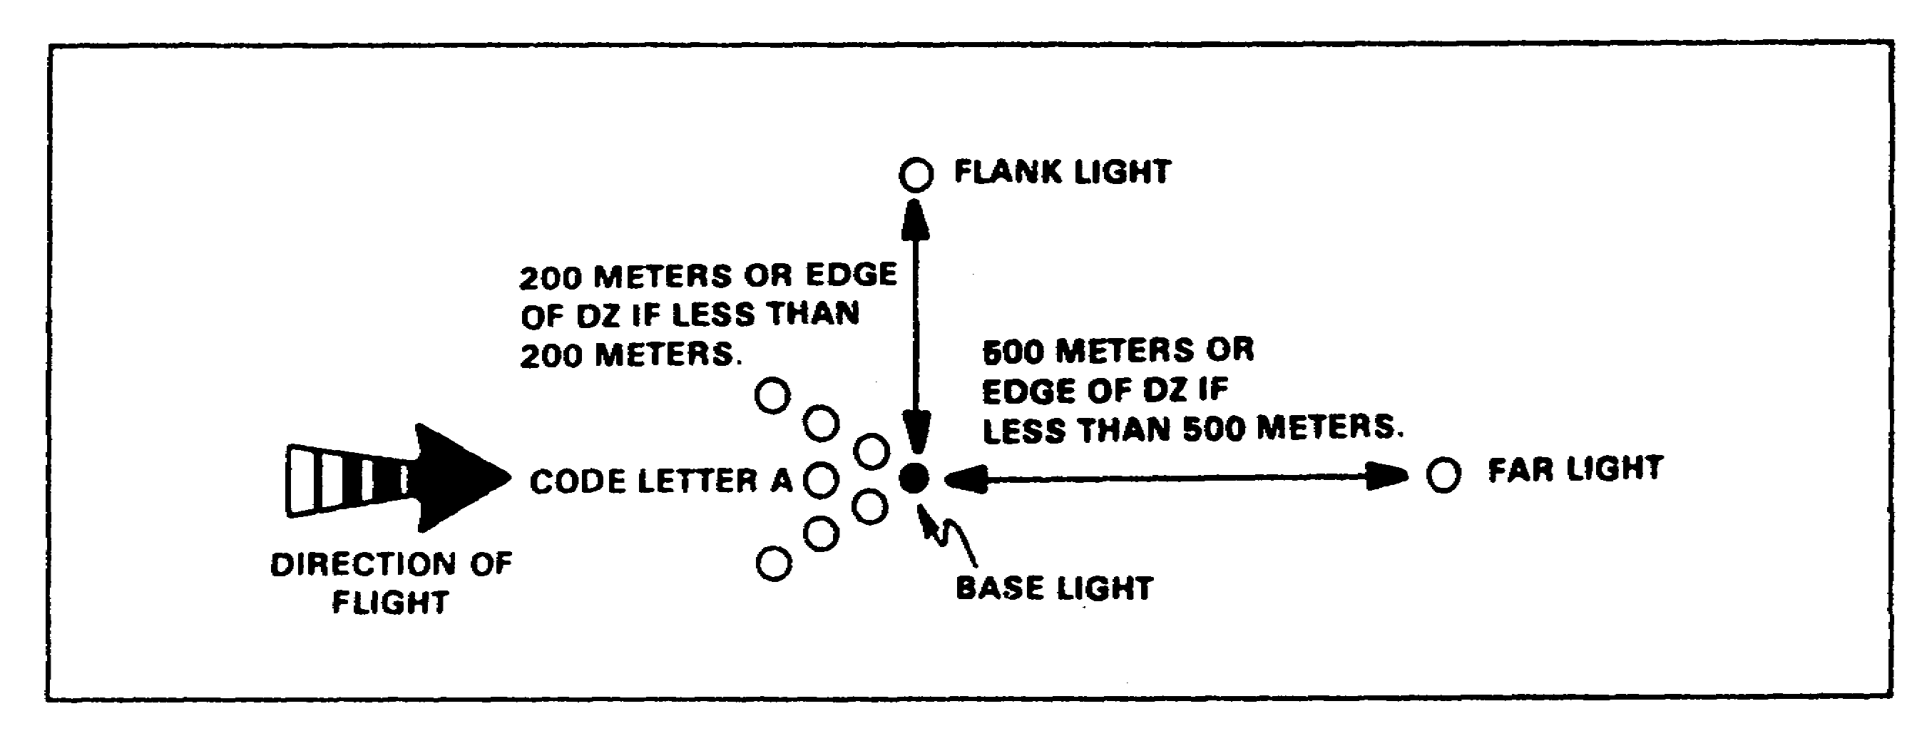

Figure 1-29. Night marking (VIRS)

(d) Option Four: Geographical Airdrops. When conditions prohibit the use of the other options, aircraft may drop on predetermined coordinates. They also may drop to a location that is marked by a forward controller, the drop zone controller (DZC), or the receiving unit.

QM 3507 1-66

PRACTICE EXERCISE

The following items will test your grasp of the material covered in this lesson. There is only one correct answer for each item. When you complete the exercise, check your answers with the answer key that follows. If you answer any item incorrectly, study again that part of the lesson which contains the portion involved.

1. In an area DZ, changes in ground elevation should not exceed how many feet?

A. 300.
B. 250.
C. 200.
D. 150.

2. You receive word that a Level III threat may jeopardize the security of your DZ. A Level III threat is represented by which of the following categories?

A. Threat-controlled agent activity.
B. Sabotage and reconnaissance missions that tactical units conduct.
C. Amphibious operations.
D. Activities that terrorist organizations conduct.

3. A C-130 aircraft that is performing a LAPE has its wheel height how many feet above the ground?

A. 1 to 4
B. 5 to 10.
C. 11 to 15.
D. 16 to 20.

4. A C-130 can carry sixteen A-22s per sortie. How many C-130 sorties are required to deliver ninety-five A-22s for airdrop?

A. Three.
B. Four.
C. Five.
D. Six.

1-67 QM 3507

5. Determine the sortie time, in hours, that is required for a C-130 aircraft with a planning speed of 280 knots. The outbound leg is 720 nm. The inbound leg is 680 nm. The turnaround time is 2 hours and 45 minutes. The time in the DZ is 15 minutes.

A. Five.
B. Six.
C. Seven.
D. Eight.

6. An initial approach zone for a LAPE is how many feet in length?

A. 500.
B. 750.
C. 10,500.
D. 11,000.

7. Cargo parachutes reduce the low-velocity airdrop rates of descent to approximately how many feet per second?

A. 14.
B. 28.
C. 90.
D. 150.

QM 3507 1-68

PRACTICE EXERCISE

ANSWER KEY AND FEEDBACK

Item Correct Answer and Feedback.

1. A. 300.

Ensure that changes in ground elevation do not exceed 300 feet or 90 meters along the flight path. (page 1-43, para la(2))

2. C. Amphibious operations.

The four Level III threat categories are ground force penetrations, airmobile operations, airborne insertions, and amphibious operations. (page 1-46, para 1c(2)(c))

3. B. 5 to 10.

A LAPE airdrop delivers platform loads from a C-130 aircraft that flies between 5 to 10 feet (wheel height) above the ground. (page 1-11, para 5b(2))

4. D. Six.

Divide the number of A-22s that are airdropped by the number of the C-22s that the aircraft can carry. The quotient is the number of the sorties that are required. (page 1-24, para 10c(3))

5. D. Eight.

Determine the time that it takes to fly the outbound leg by dividing the distance by the planning speed of the aircraft. Determine the time that it takes to fly the return leg by dividing the distance by the planning speed of the aircraft. Add the turnaround time, the time in the DZ, the time to fly the outbound leg, and the time to fly the inbound leg. (page 1-26, para 10d(2))

6. C. 10,500.

The LAPE initial approach zone is 10,500 feet long. It starts at 11,000 feet and ends at 500 feet. (page 1-47, para le(l)(a))

1-69 QM 3507

7. B. 28.

Use low-velocity airdrop for all supplies and equipment that are certified for airdrop. Cargo parachutes reduce the rate of the descent to no more than 28 feet per second. (page 1-4, para 2b)

QM 3507 1-70

